**Spring Basics**

**DelegatingFilterProxy**:

Spring provides a Filter implementation named DelegatingFilterProxy that allows bridging between the Servlet container’s lifecycle and Spring’s ApplicationContext. The Servlet container allows registering Filters using its own standards, but it is not aware of Spring defined Beans. DelegatingFilterProxy can be registered via standard Servlet container mechanisms, but delegate all the work to a Spring Bean that implements Filter.

Here is a picture of how DelegatingFilterProxy fits into the Filters and the FilterChain.

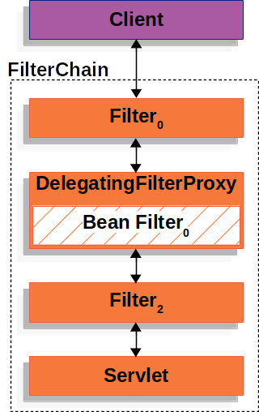

**FilterChainProxy** :

In the Multiple **SecurityFilterChain** Figure **FilterChainProxy** decides which SecurityFilterChain should be used. Only the first SecurityFilterChain that matches will be invoked. If a URL of /api/messages/ is requested, it will first match on SecurityFilterChain0's pattern of /api/**, so only SecurityFilterChain0 will be invoked even though it also matches on SecurityFilterChainn. If a URL of /messages/ is requested, it will not match on SecurityFilterChain0's pattern of /api/**, so FilterChainProxy will continue trying each SecurityFilterChain. Assuming that no other, SecurityFilterChain instances match SecurityFilterChainn will be invoked.

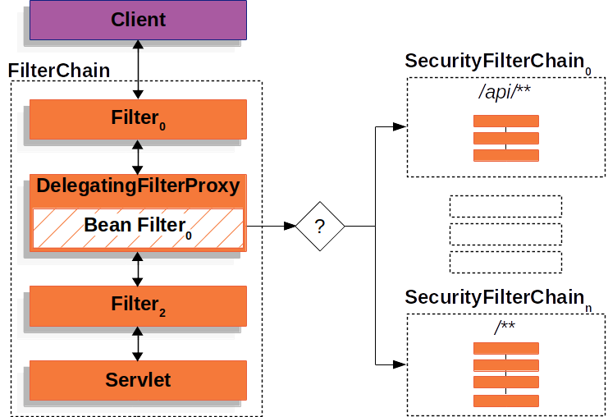

**Security Filters**

The Security Filters are inserted into the [FilterChainProxy](https://docs.spring.io/spring-security/site/docs/current/reference/html5/#servlet-filterchainproxy) with the [SecurityFilterChain](https://docs.spring.io/spring-security/site/docs/current/reference/html5/#servlet-securityfilterchain) API. The [order of Filter](https://docs.spring.io/spring-security/site/docs/current/reference/html5/#servlet-filters-review)s matters. It is typically not necessary to know the ordering of Spring Security’s Filters. However, there are times that it is beneficial to know the ordering

Below is a comprehensive list of Spring Security Filter ordering:

* ChannelProcessingFilter
* WebAsyncManagerIntegrationFilter
* SecurityContextPersistenceFilter
* HeaderWriterFilter
* CorsFilter
* CsrfFilter
* LogoutFilter
* OAuth2AuthorizationRequestRedirectFilter
* Saml2WebSsoAuthenticationRequestFilter
* X509AuthenticationFilter
* AbstractPreAuthenticatedProcessingFilter
* CasAuthenticationFilter
* OAuth2LoginAuthenticationFilter
* Saml2WebSsoAuthenticationFilter
* [UsernamePasswordAuthenticationFilter](https://docs.spring.io/spring-security/site/docs/current/reference/html5/#servlet-authentication-usernamepasswordauthenticationfilter)
* OpenIDAuthenticationFilter
* DefaultLoginPageGeneratingFilter
* DefaultLogoutPageGeneratingFilter
* ConcurrentSessionFilter
* [DigestAuthenticationFilter](https://docs.spring.io/spring-security/site/docs/current/reference/html5/#servlet-authentication-digest)
* BearerTokenAuthenticationFilter
* [BasicAuthenticationFilter](https://docs.spring.io/spring-security/site/docs/current/reference/html5/#servlet-authentication-basic)
* RequestCacheAwareFilter
* SecurityContextHolderAwareRequestFilter
* JaasApiIntegrationFilter
* RememberMeAuthenticationFilter
* AnonymousAuthenticationFilter
* OAuth2AuthorizationCodeGrantFilter
* SessionManagementFilter
* [ExceptionTranslationFilter](https://docs.spring.io/spring-security/site/docs/current/reference/html5/#servlet-exceptiontranslationfilter)
* [FilterSecurityInterceptor](https://docs.spring.io/spring-security/site/docs/current/reference/html5/#servlet-authorization-filtersecurityinterceptor)
* SwitchUserFilter

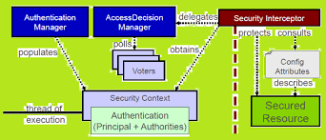

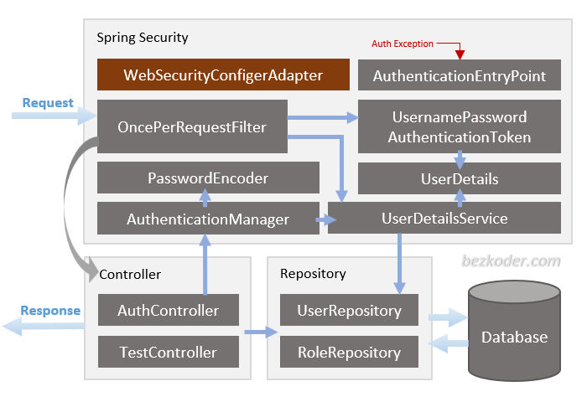

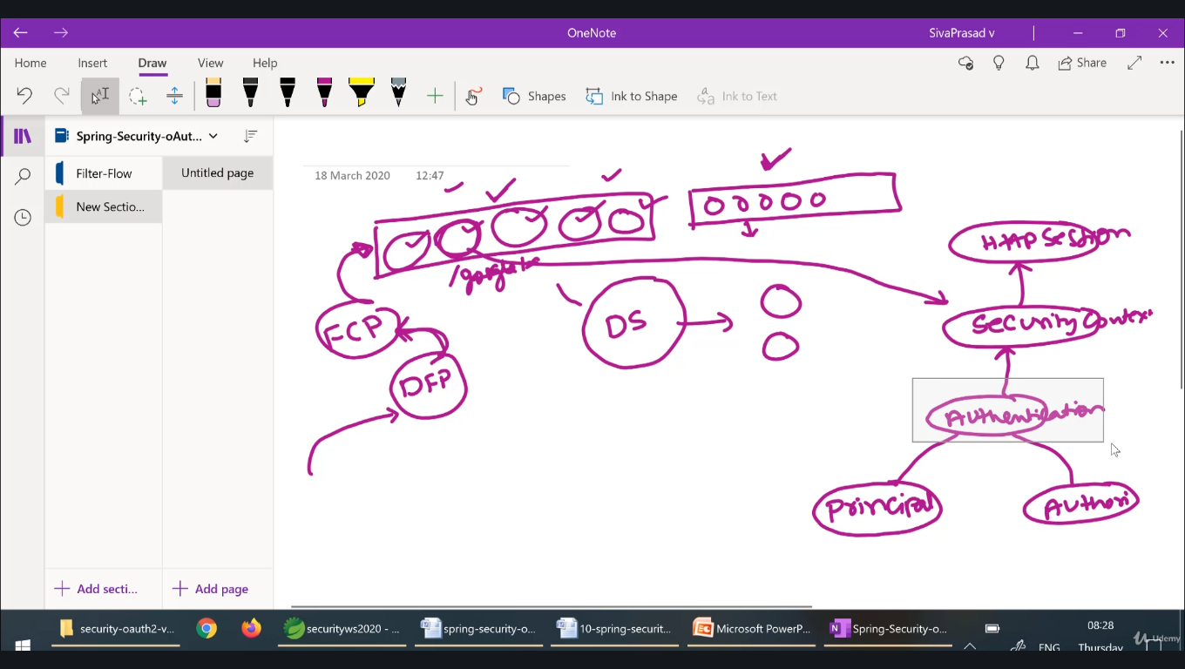

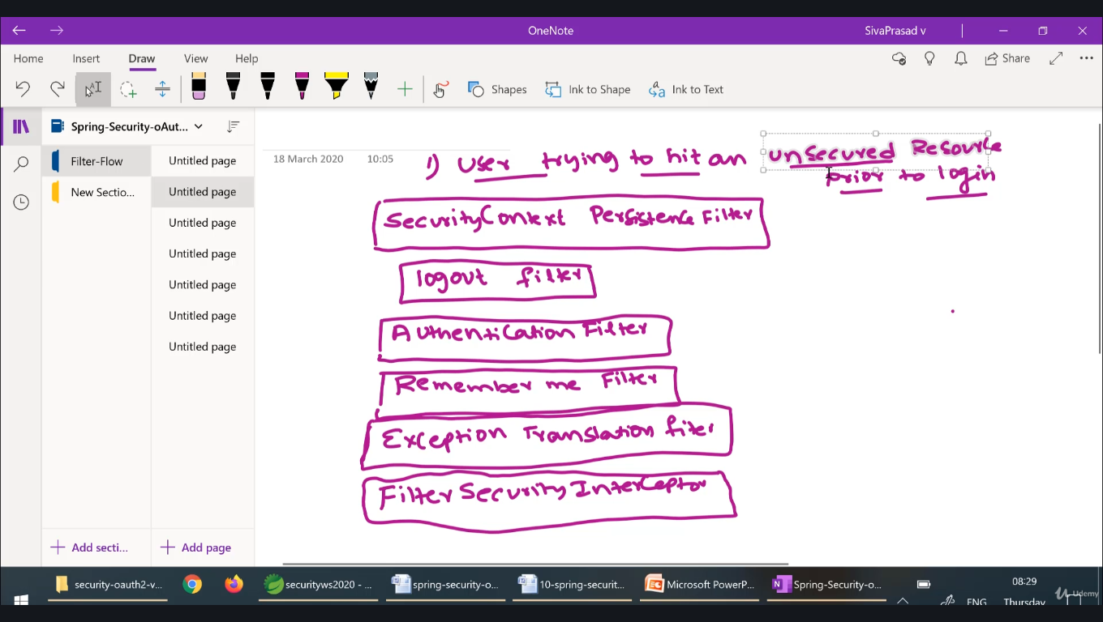

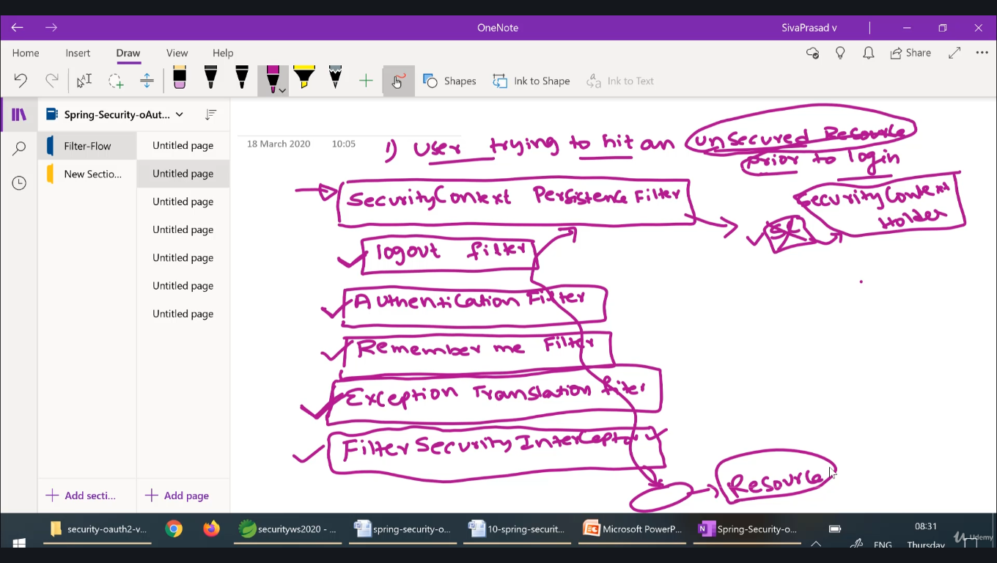

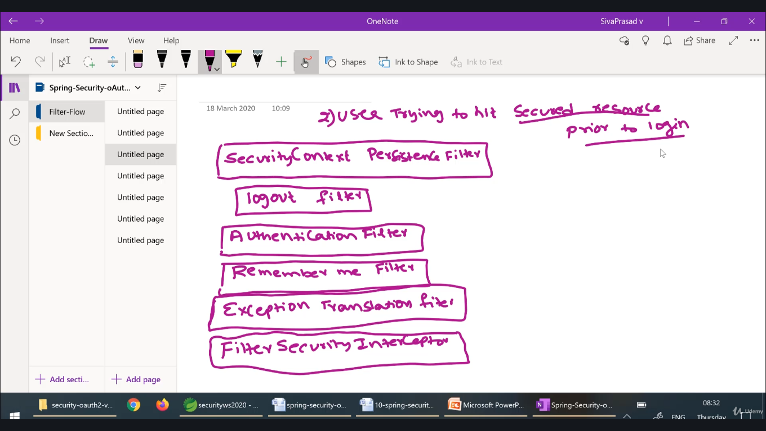

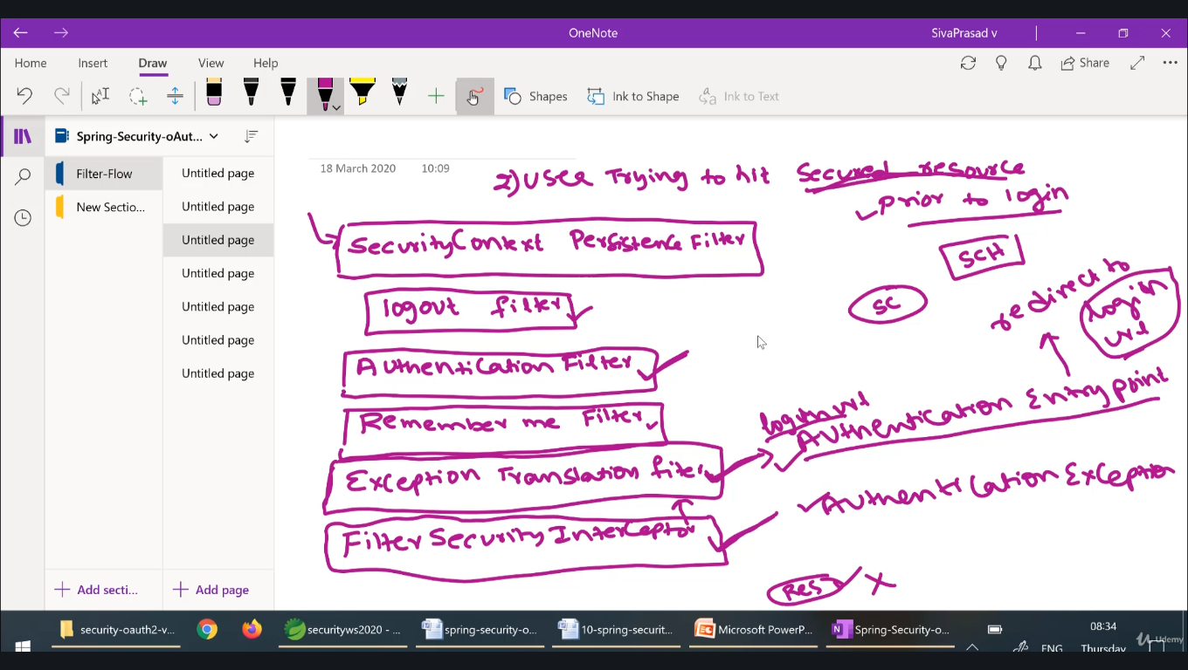

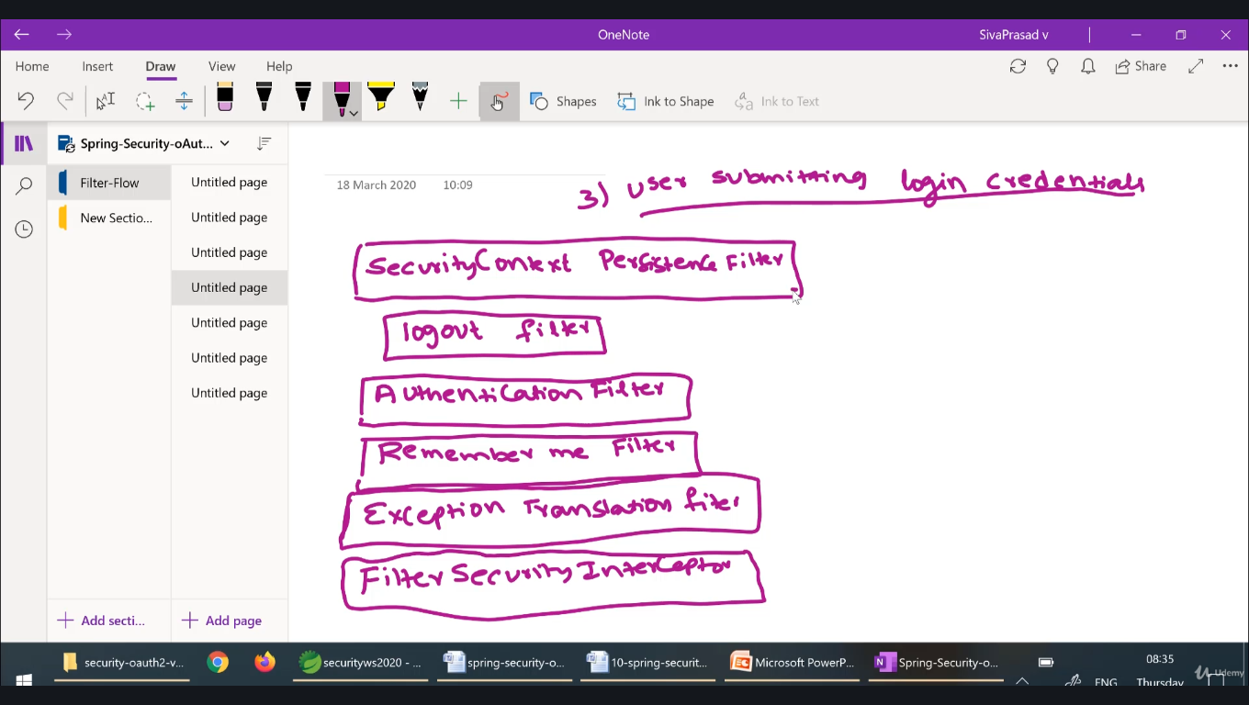

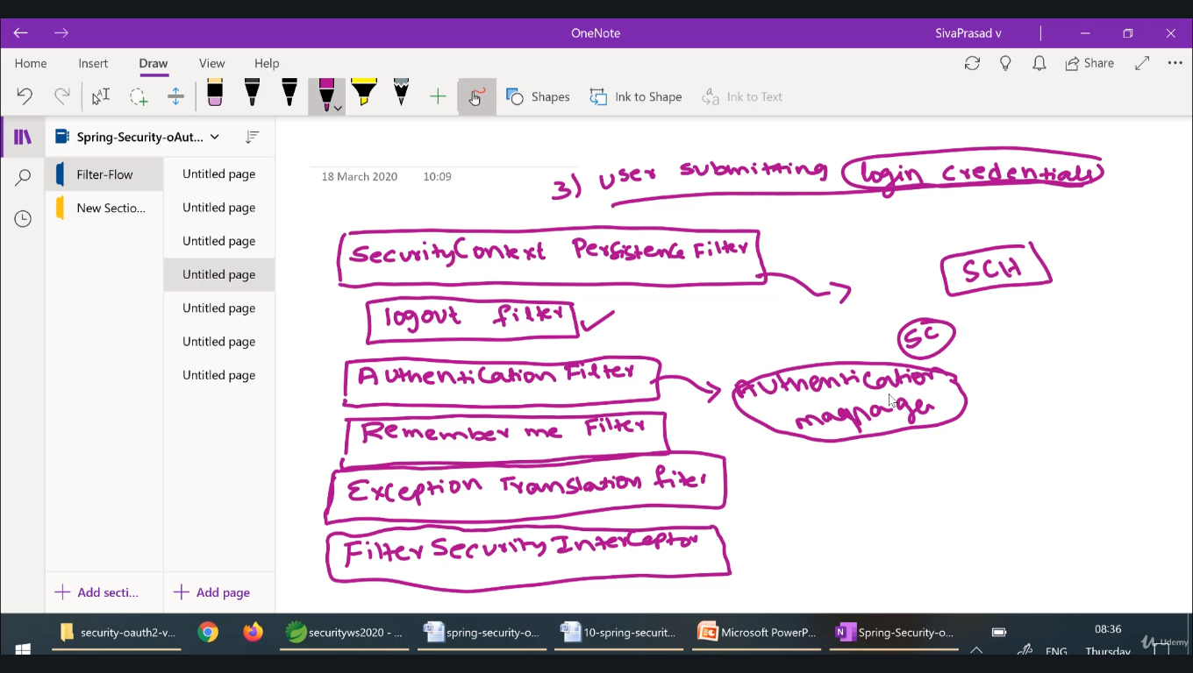

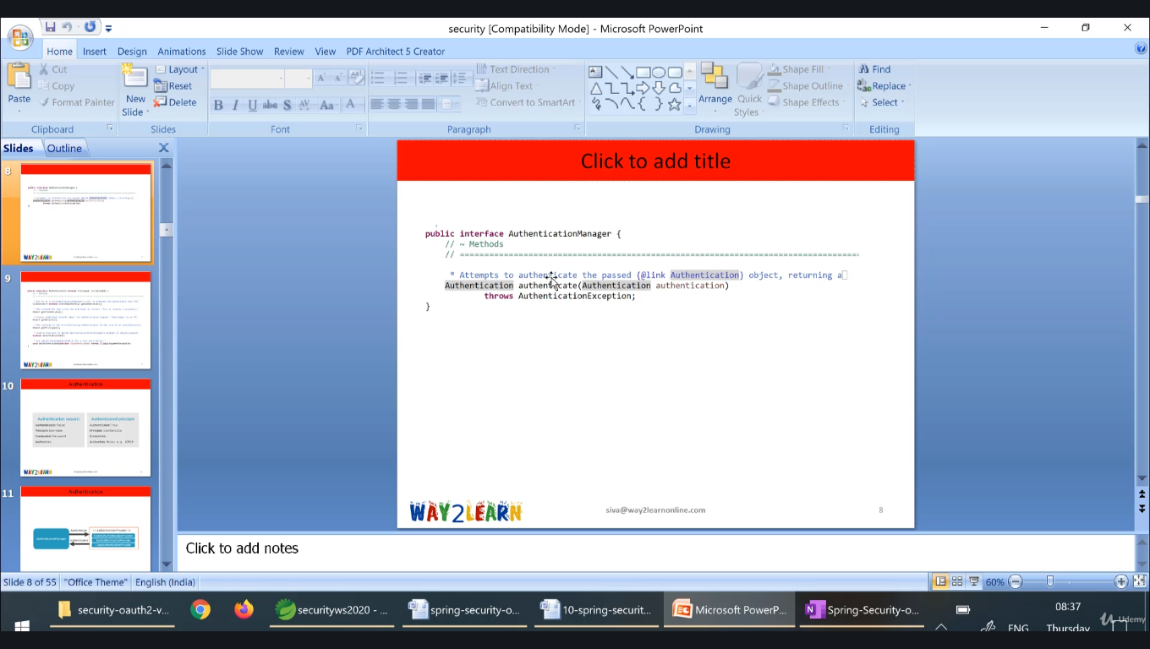

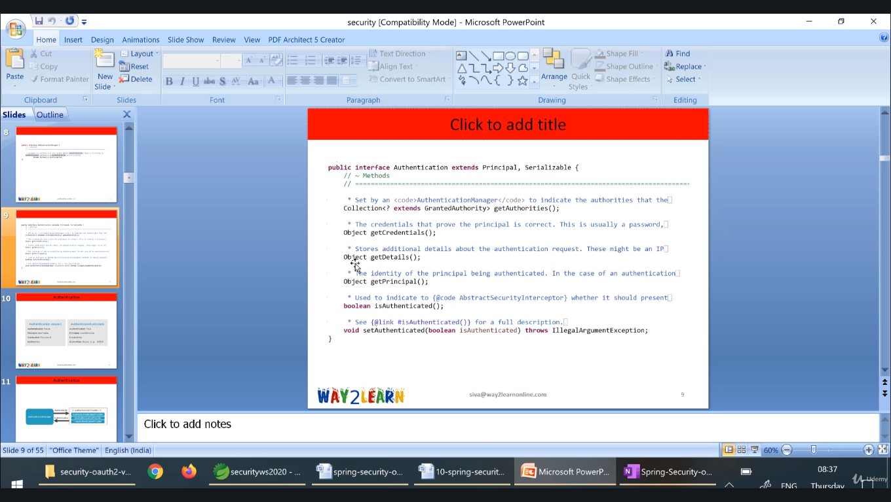

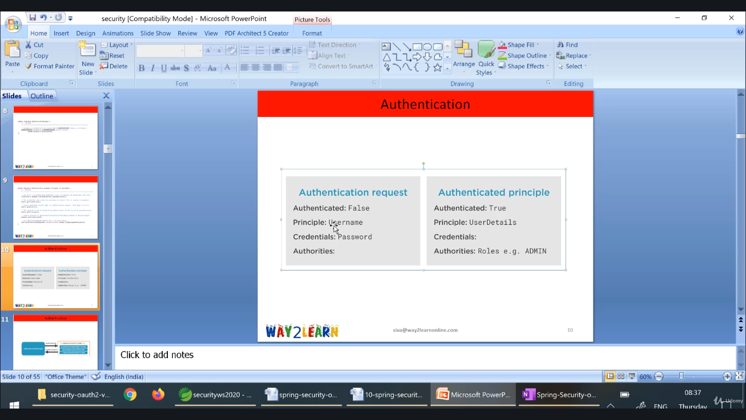

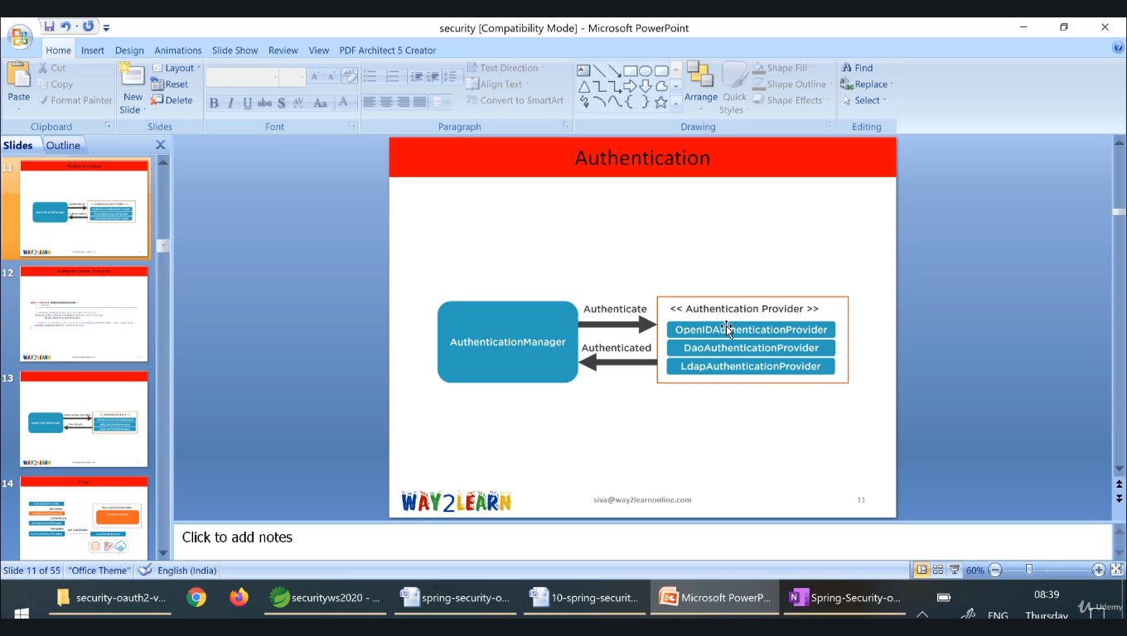

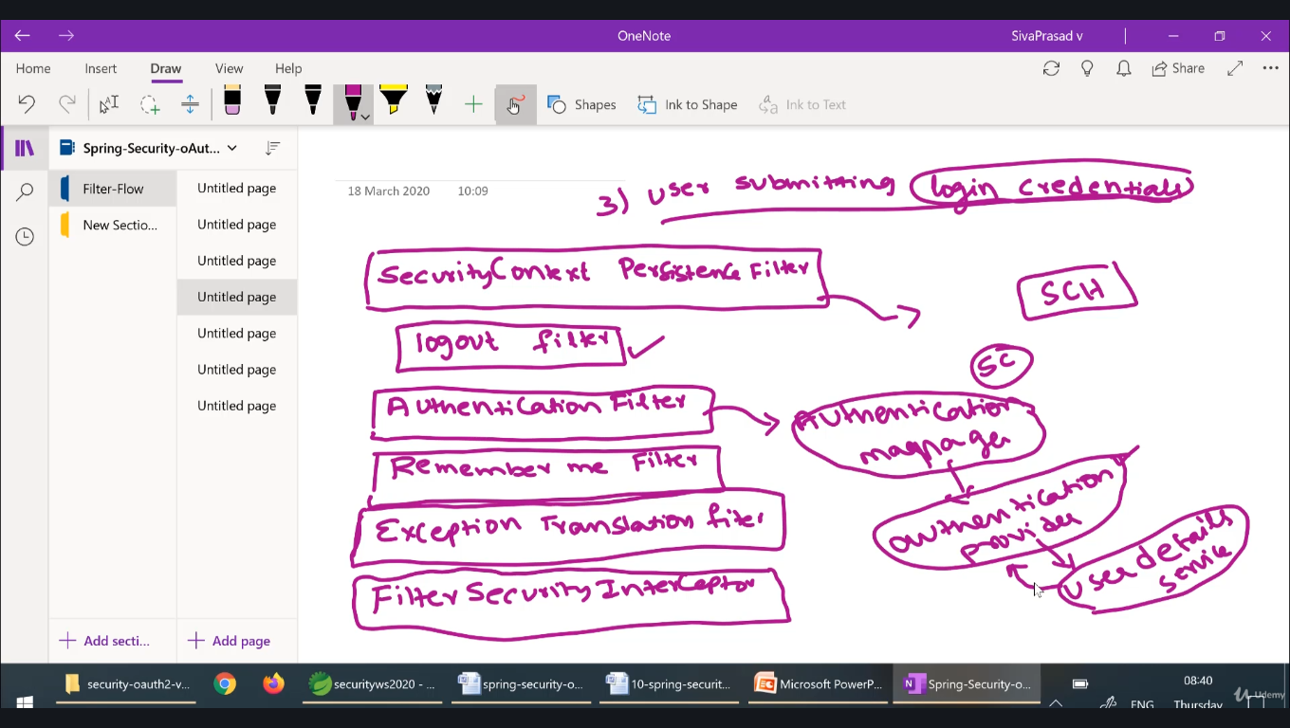

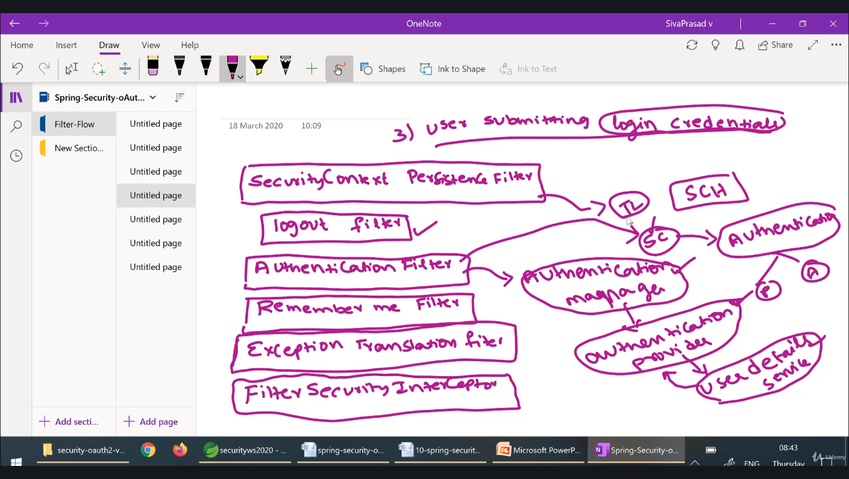

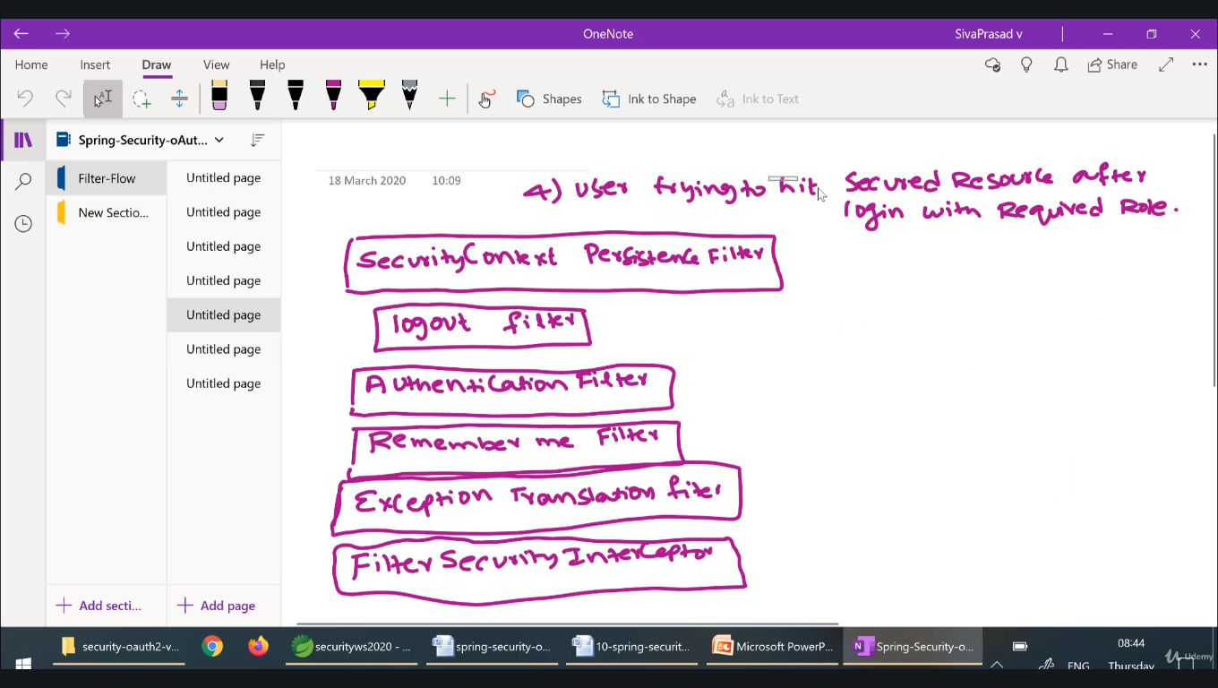

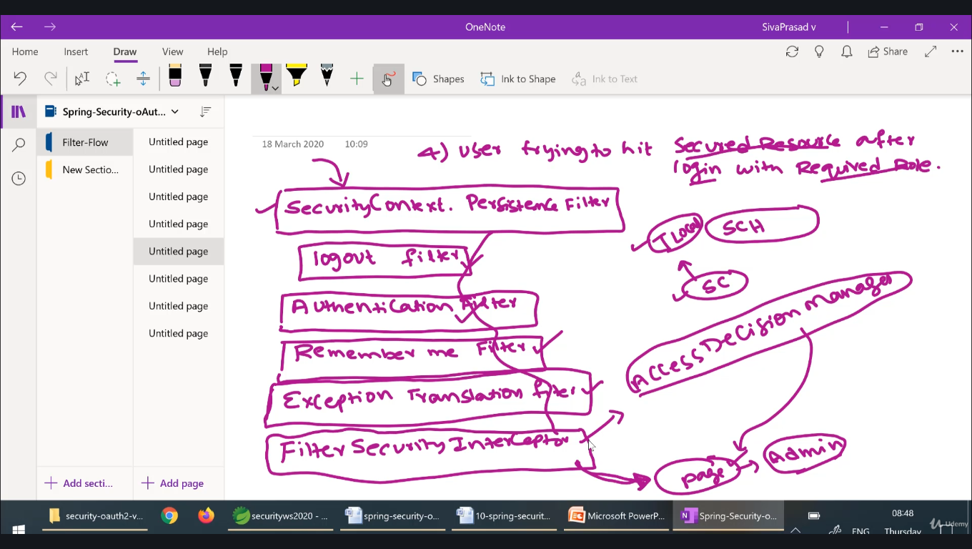

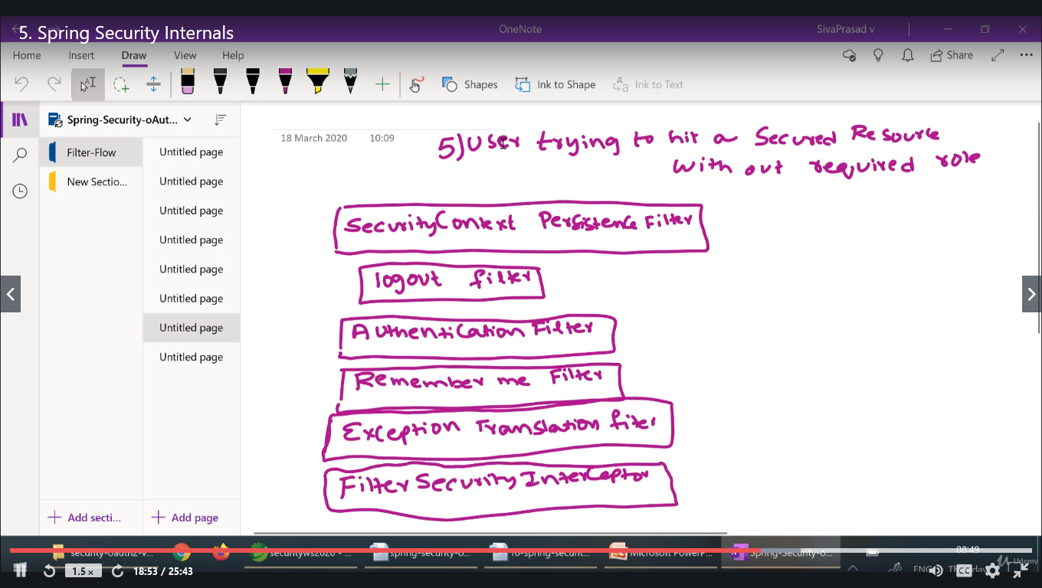

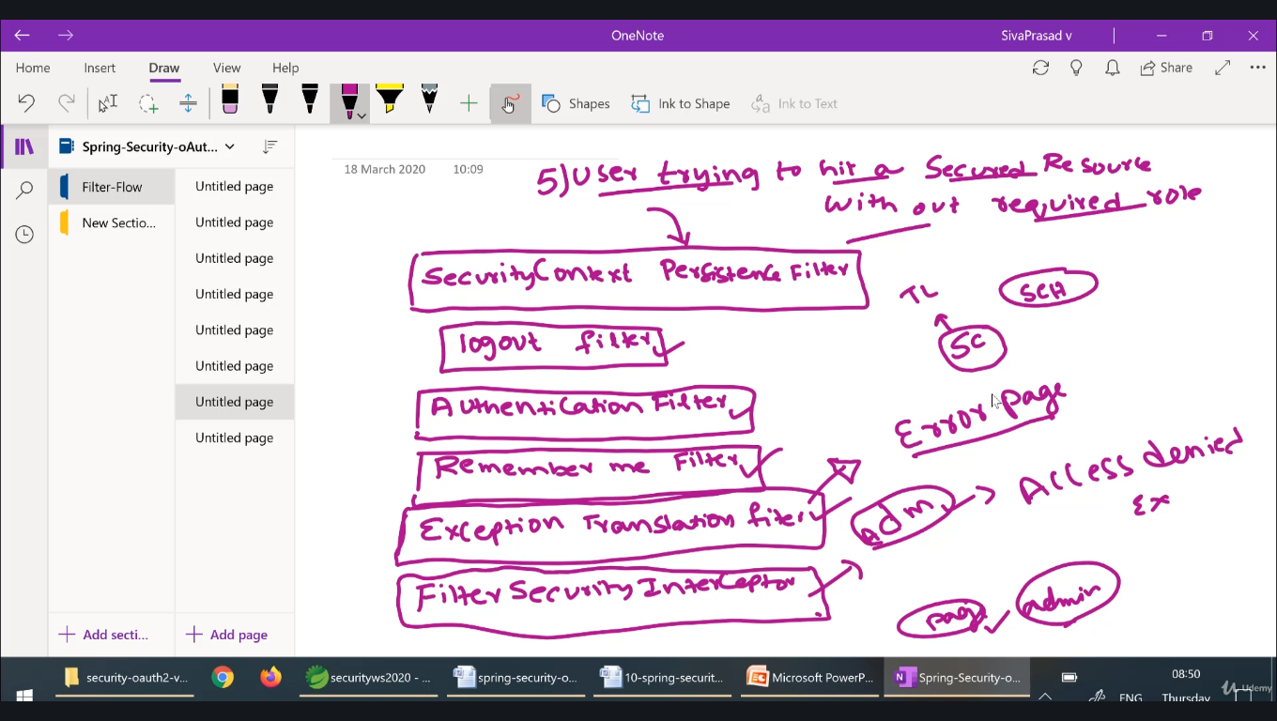

## FilterSecurityInterceptor

We've already seen FilterSecurityInterceptor briefly when discussing [access-control in general](https://docs.spring.io/spring-security/site/docs/3.2.0.CI-SNAPSHOT/reference/html/technical-overview.html#tech-intro-access-control), and we've already used it with the namespace where the <intercept-url> elements are combined to configure it internally. Now we'll see how to explicitly configure it for use with a FilterChainProxy, along with its companion filter ExceptionTranslationFilter. A typical configuration example is shown below:

<bean id="filterSecurityInterceptor"

class="org.springframework.security.web.access.intercept.FilterSecurityInterceptor">

<property name="authenticationManager" ref="authenticationManager"/>

<property name="accessDecisionManager" ref="accessDecisionManager"/>

<property name="securityMetadataSource">

<security:filter-security-metadata-source>

<security:intercept-url pattern="/secure/super/**" access="ROLE_WE_DONT_HAVE"/>

<security:intercept-url pattern="/secure/**" access="ROLE_SUPERVISOR,ROLE_TELLER"/>

</security:filter-security-metadata-source>

</property>

</bean>

FilterSecurityInterceptor is responsible for handling the security of HTTP resources. It requires a reference to an AuthenticationManager and an AccessDecisionManager. It is also supplied with configuration attributes that apply to different HTTP URL requests. Refer back to [the original discussion on these](https://docs.spring.io/spring-security/site/docs/3.2.0.CI-SNAPSHOT/reference/html/technical-overview.html#tech-intro-config-attributes) in the technical introduction.

The FilterSecurityInterceptor can be configured with configuration attributes in two ways. The first, which is shown above, is using the <filter-security-metadata-source> namespace element. This is similar to the <http> element from the namespace chapter but the <intercept-url> child elements only use the pattern and access attributes. Commas are used to delimit the different configuration attributes that apply to each HTTP URL. The second option is to write your own SecurityMetadataSource, but this is beyond the scope of this document. Irrespective of the approach used, the SecurityMetadataSource is responsible for returning a List<ConfigAttribute> containing all of the configuration attributes associated with a single secure HTTP URL.

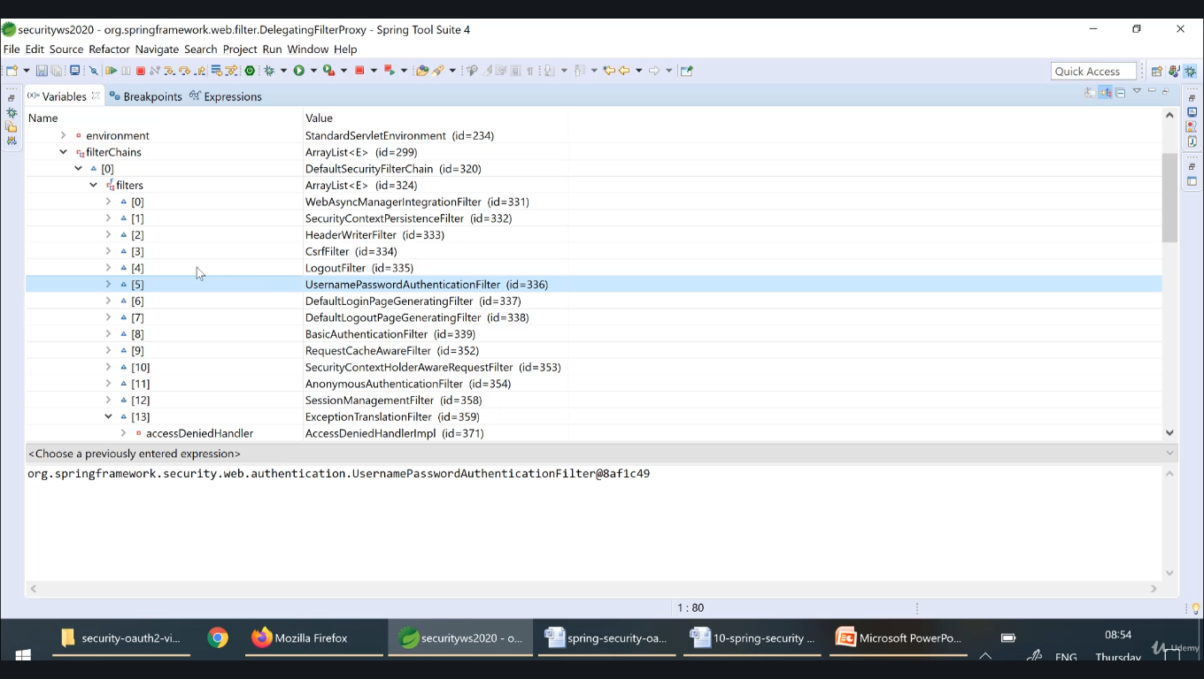

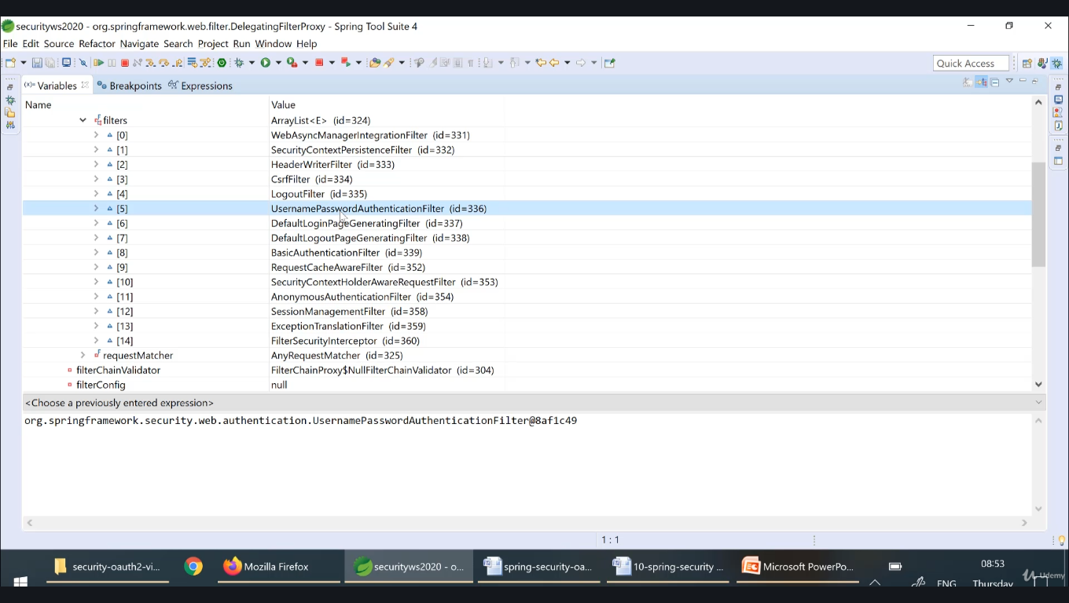

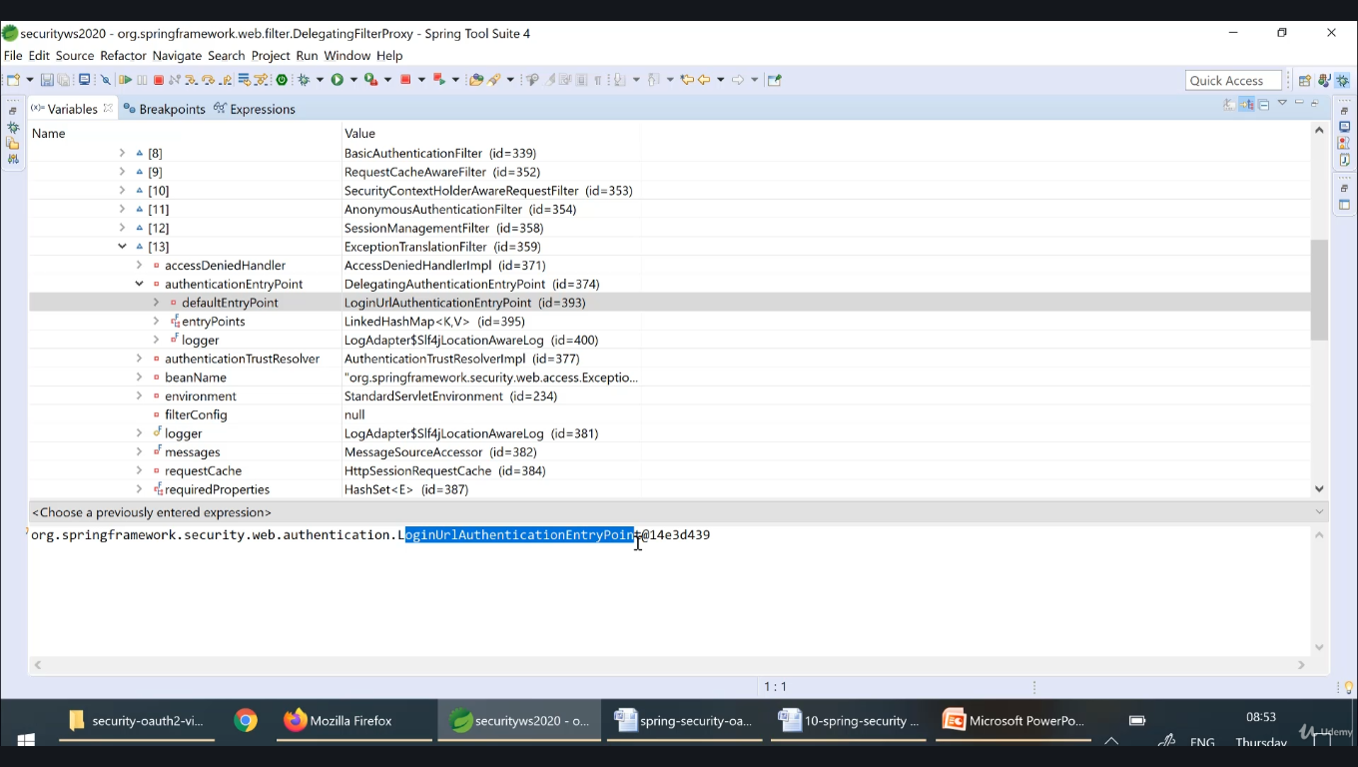

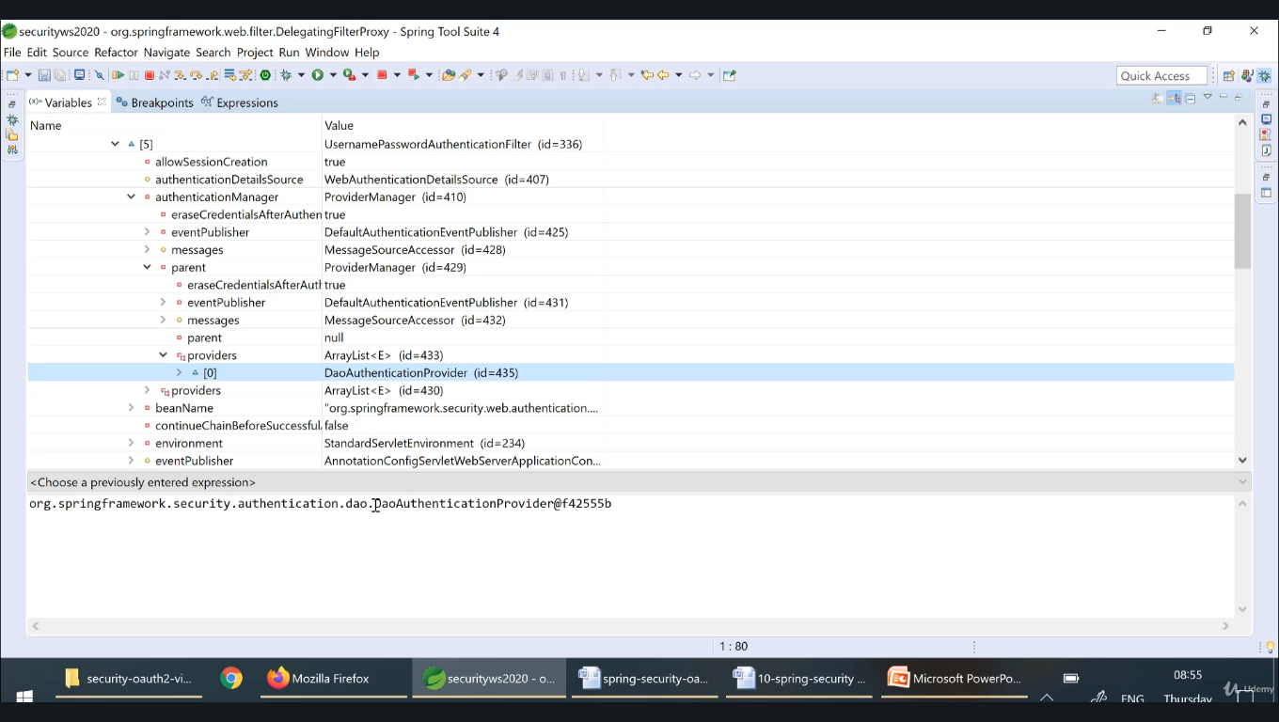

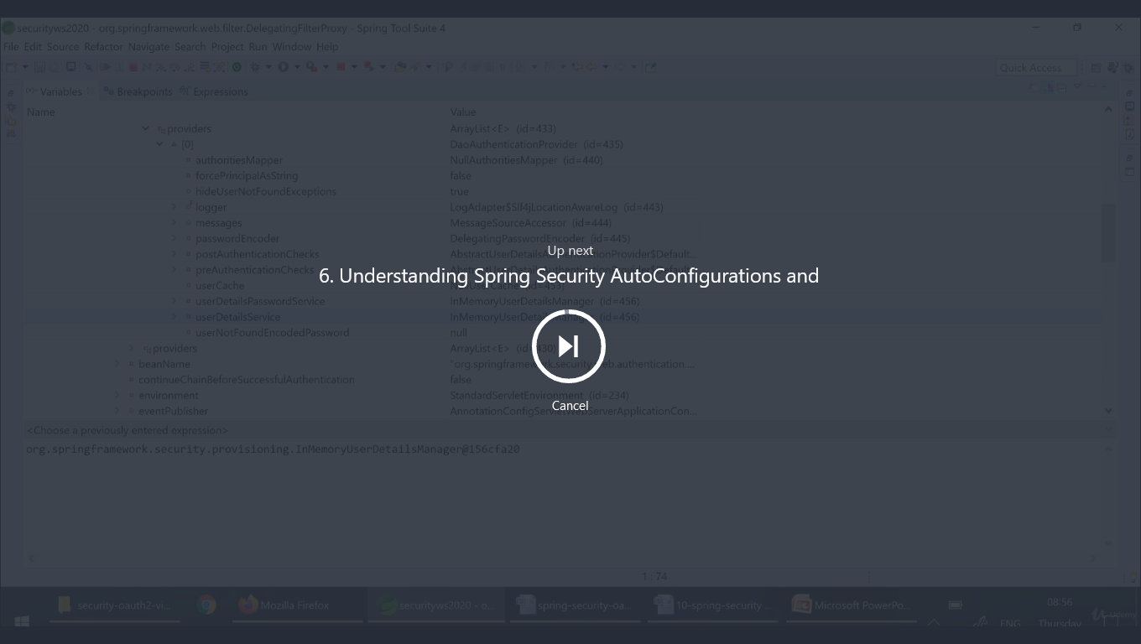

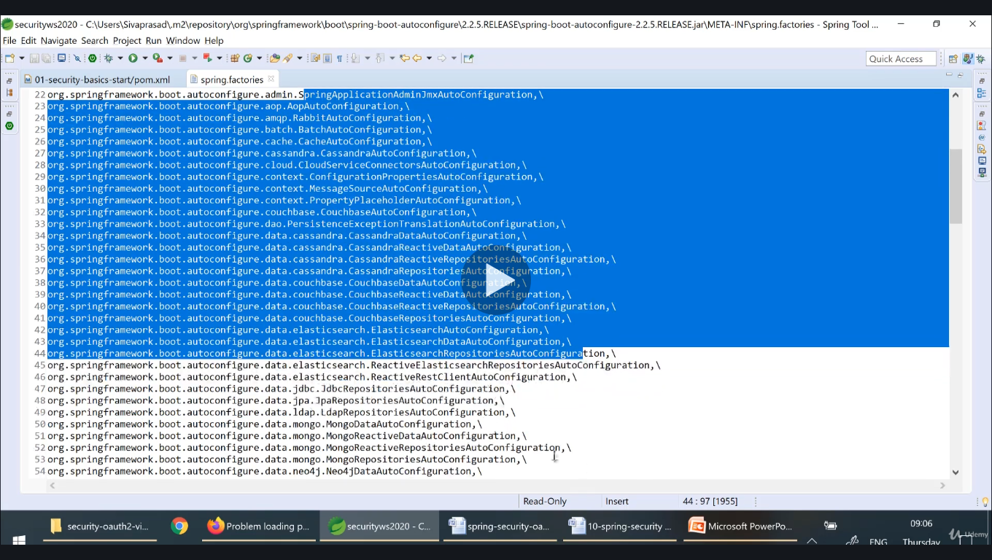

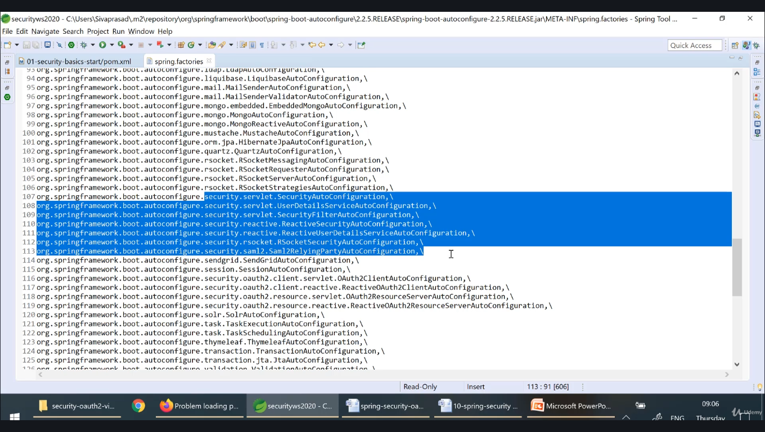

**SecurityAutoConfiguration**

**UserDetailsServiceAutoconfiguration**

**SecurityFilterAutoConfiguration**

**SecurityAutoConfiguration:**

**a.**SpringBootWebSecurityConfiguration b. WebSecurityEnablerConfiguration c.SecurityDataConfiguration

**EnableWebsecurity annotation enables : SpringsecurityFilterchain**

**WebSecurityConfigurationAdapter abs class will be used to configure security configurations. This needs to override to configure custom httpconfiguration**

**DeligatingFilterproxy is configured by securityFilterAutoconfiguration**

We can configure multiple **WebSecurityConfigurationAdapter using order, it creates multiple filterchains**

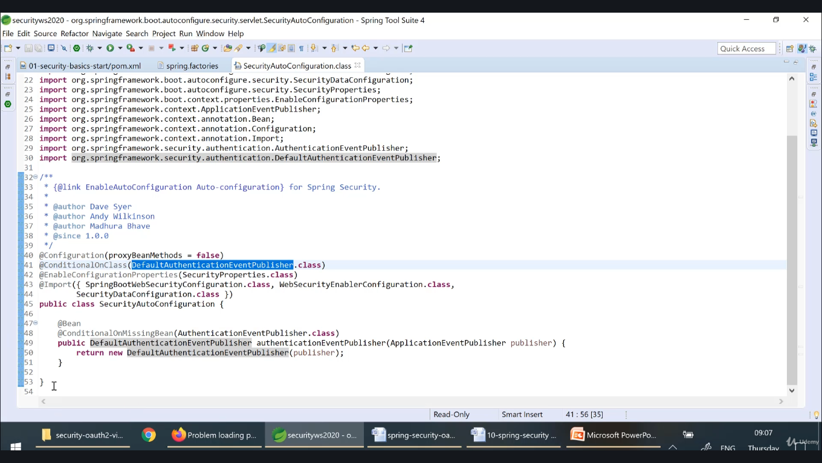

**DefaultAuthenticationEventPublisher class is from Spring security jar.**

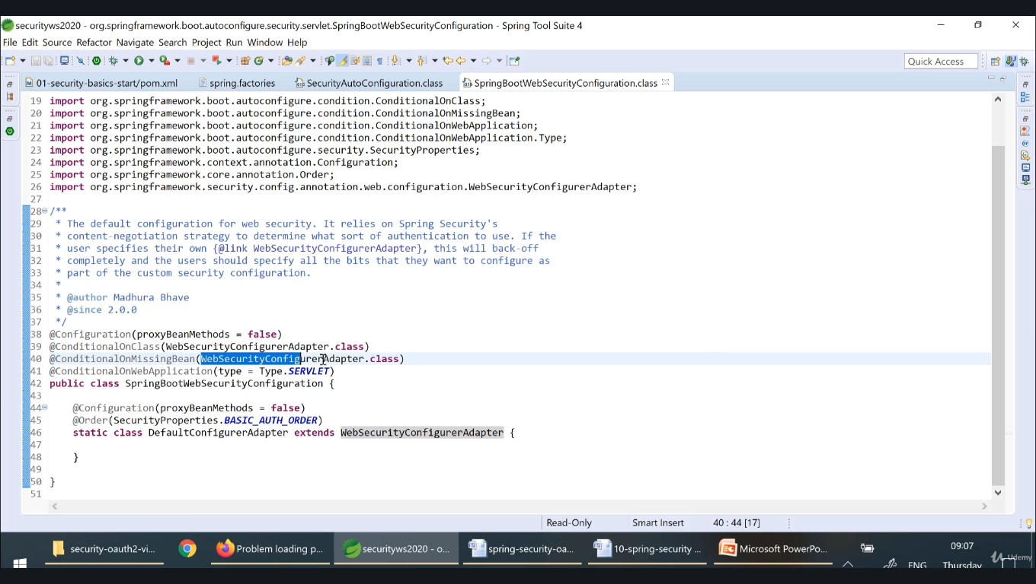

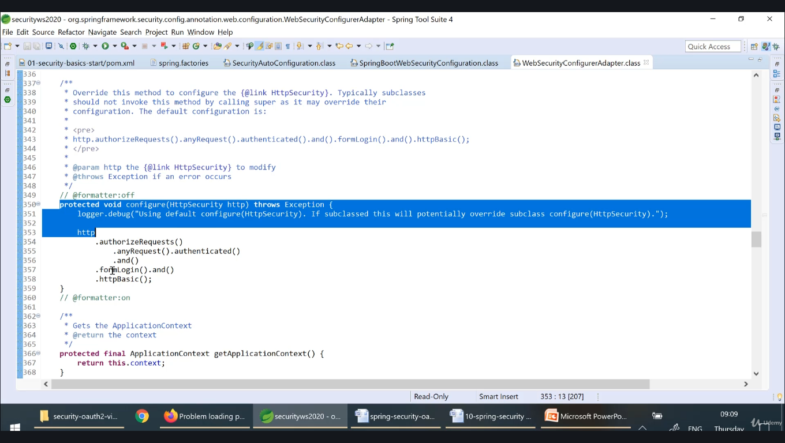

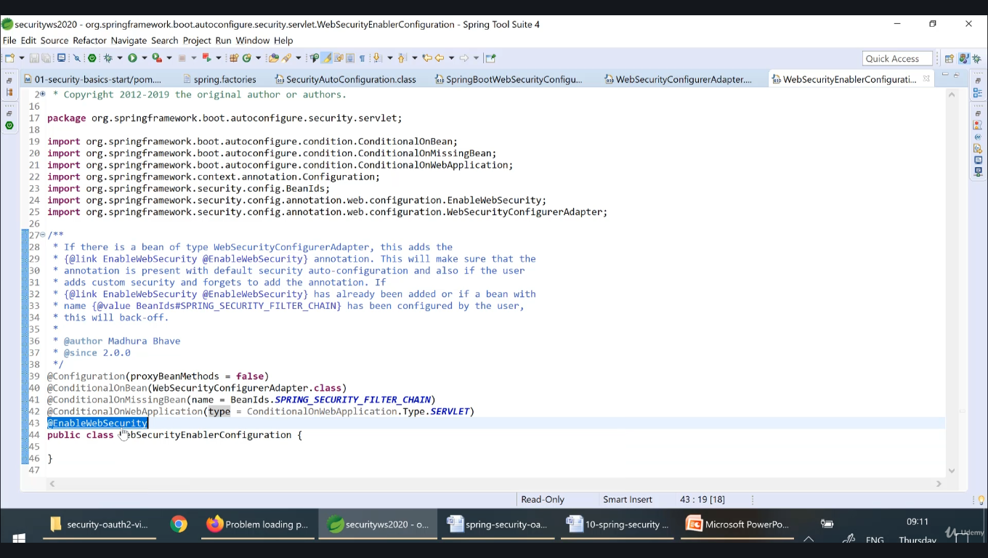

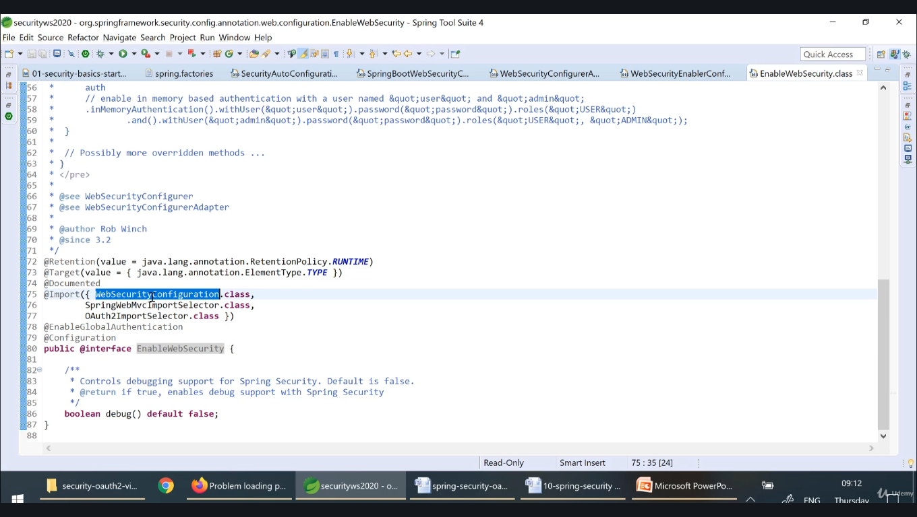

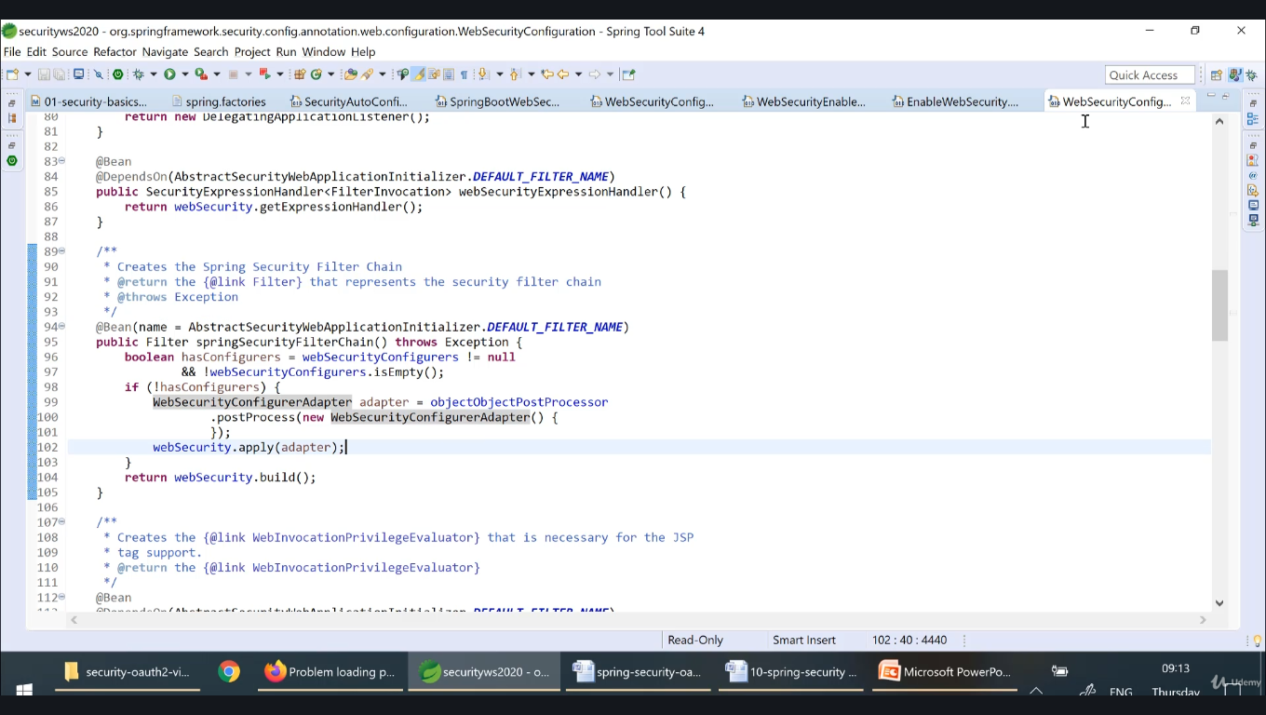

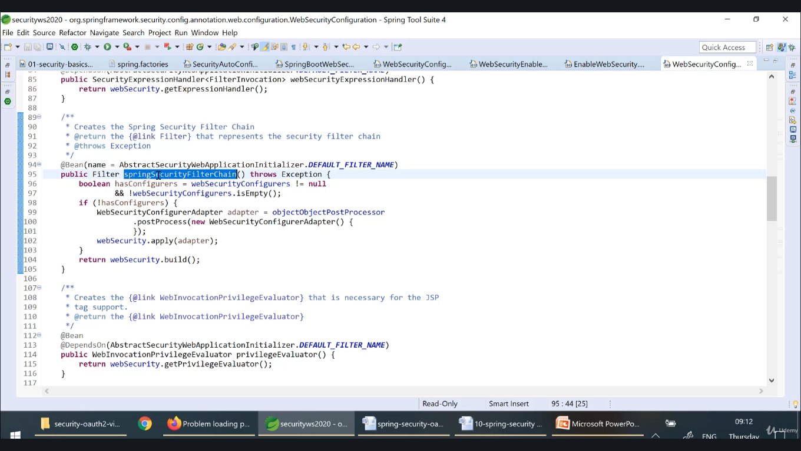

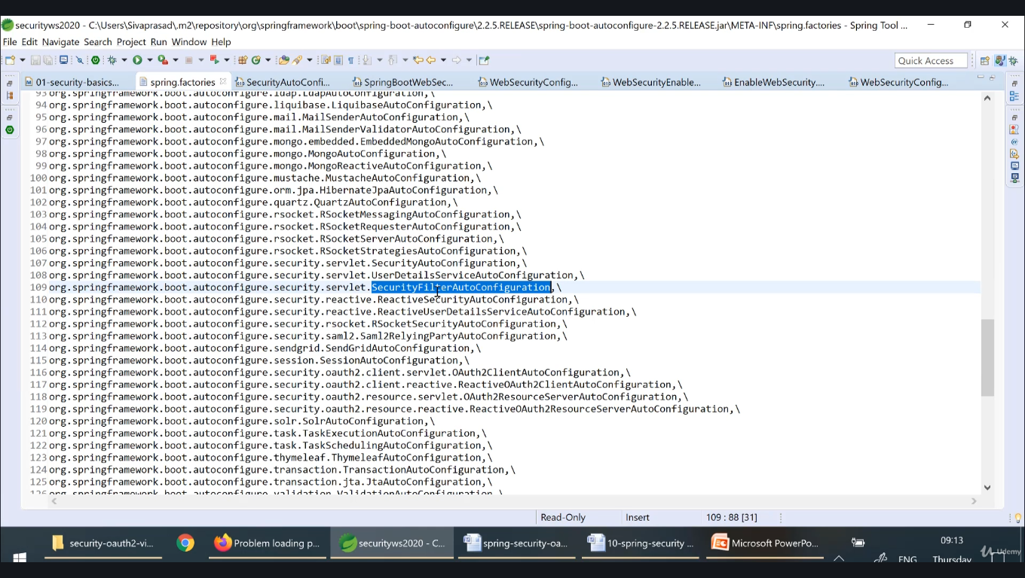

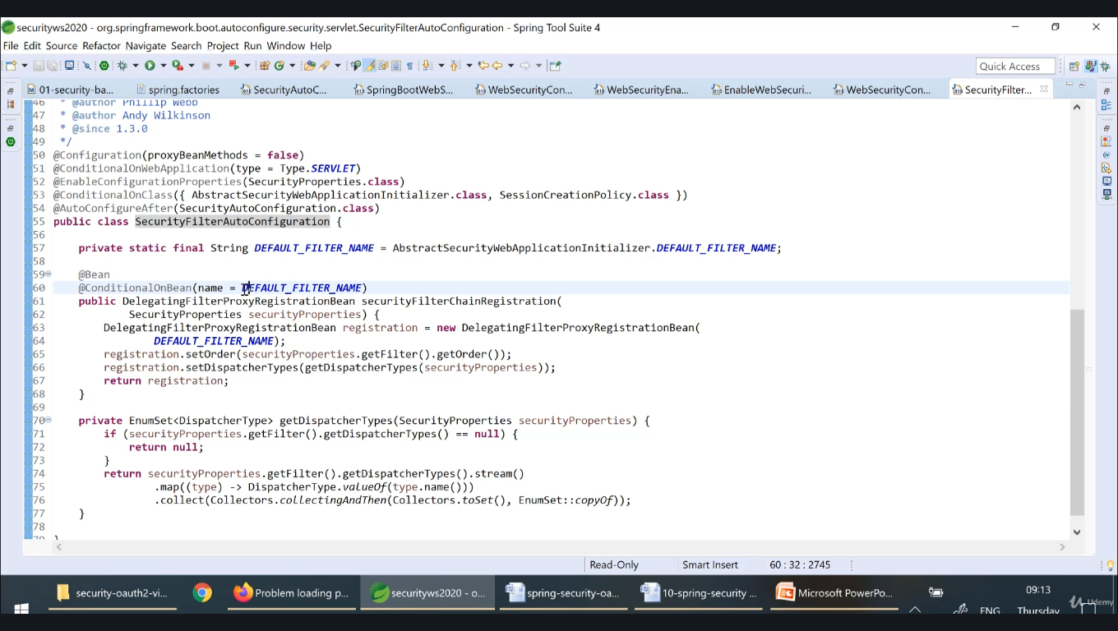

**By default, a user will be created and password will be printed on console, this is configured under userdetailsserviceAutoconfiguration**

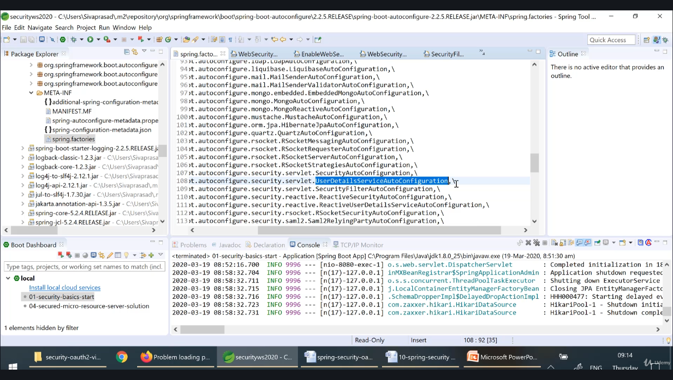

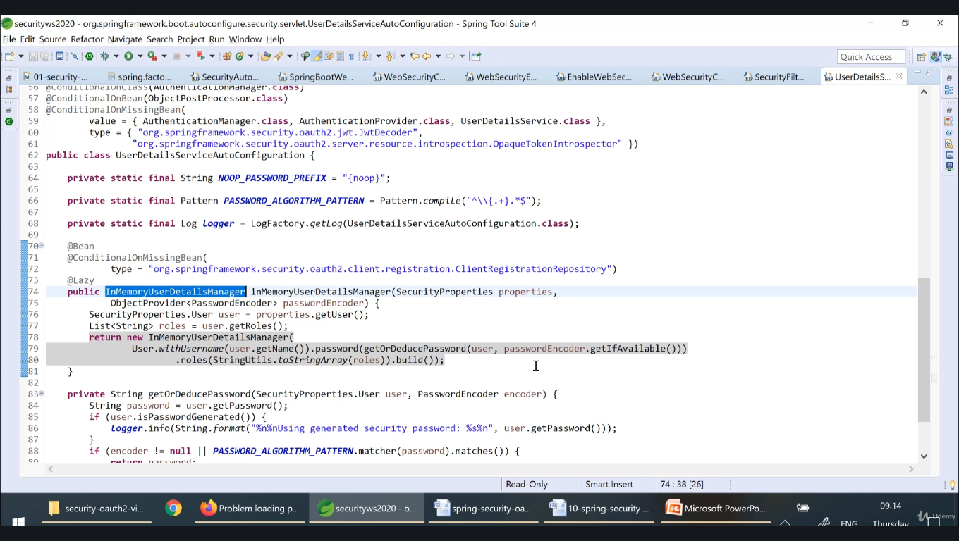

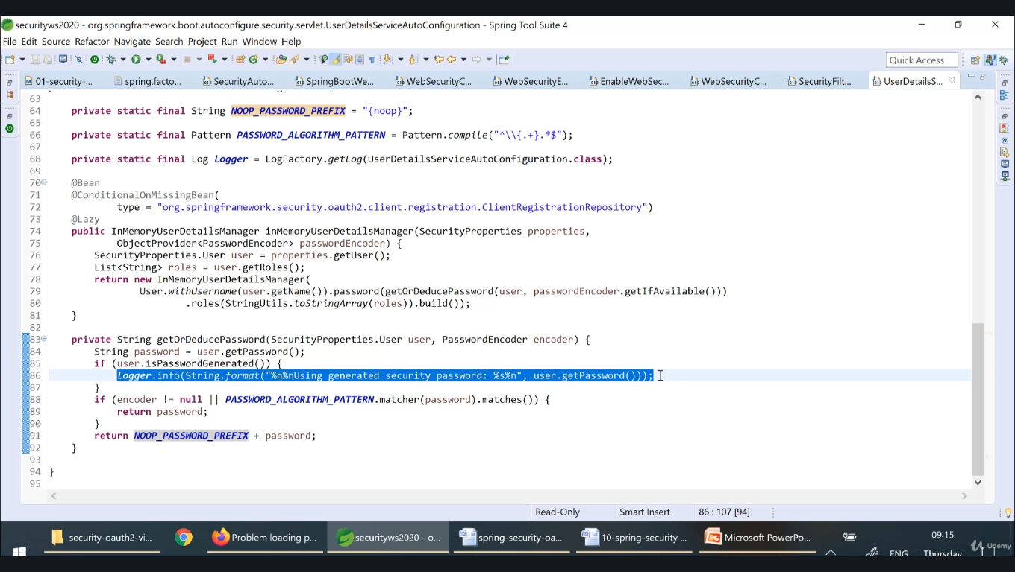

**If we want to override default behaviour of spring security then we need to override class WebSecurityConfigurationAdapter method configure(HttpSecurity http)**

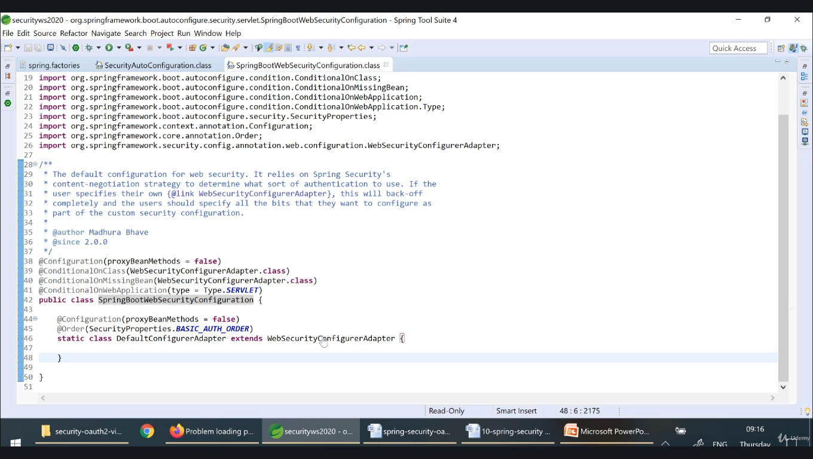

**Example :** 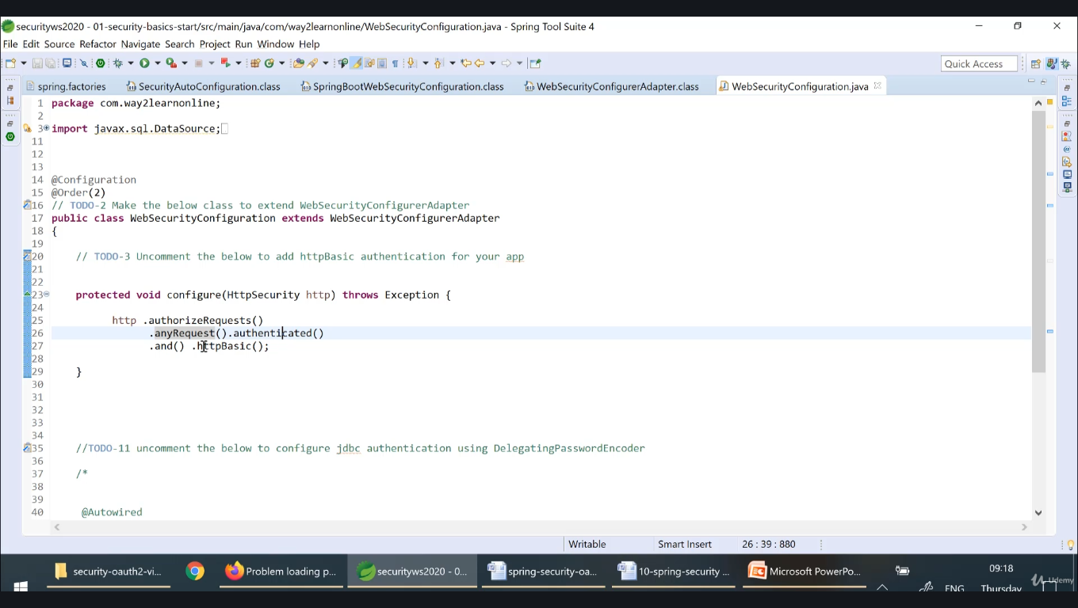

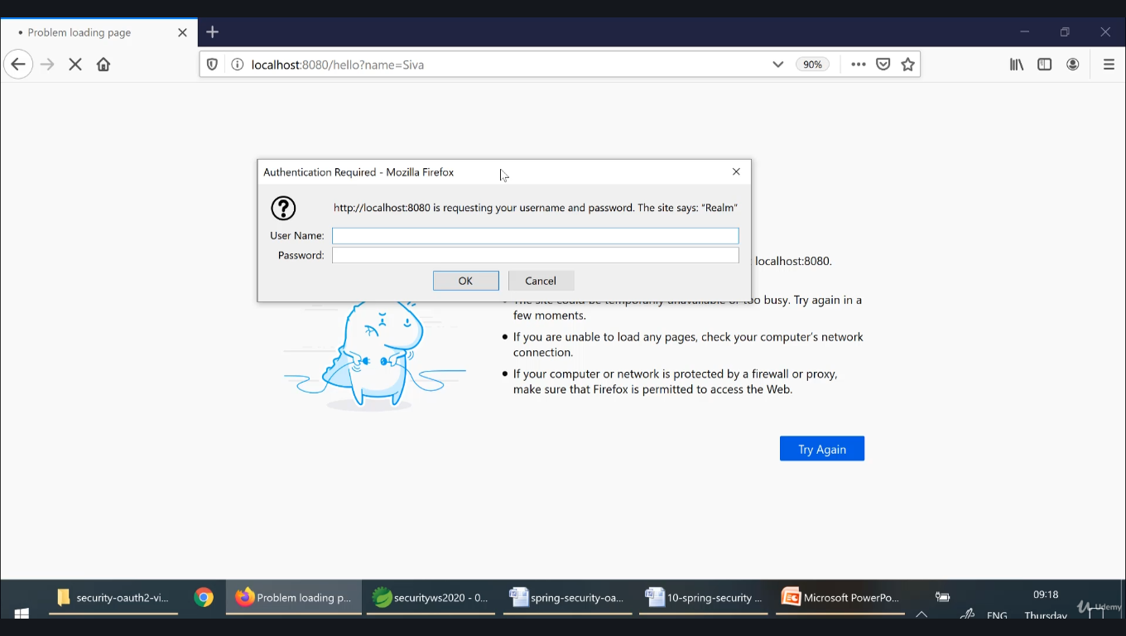

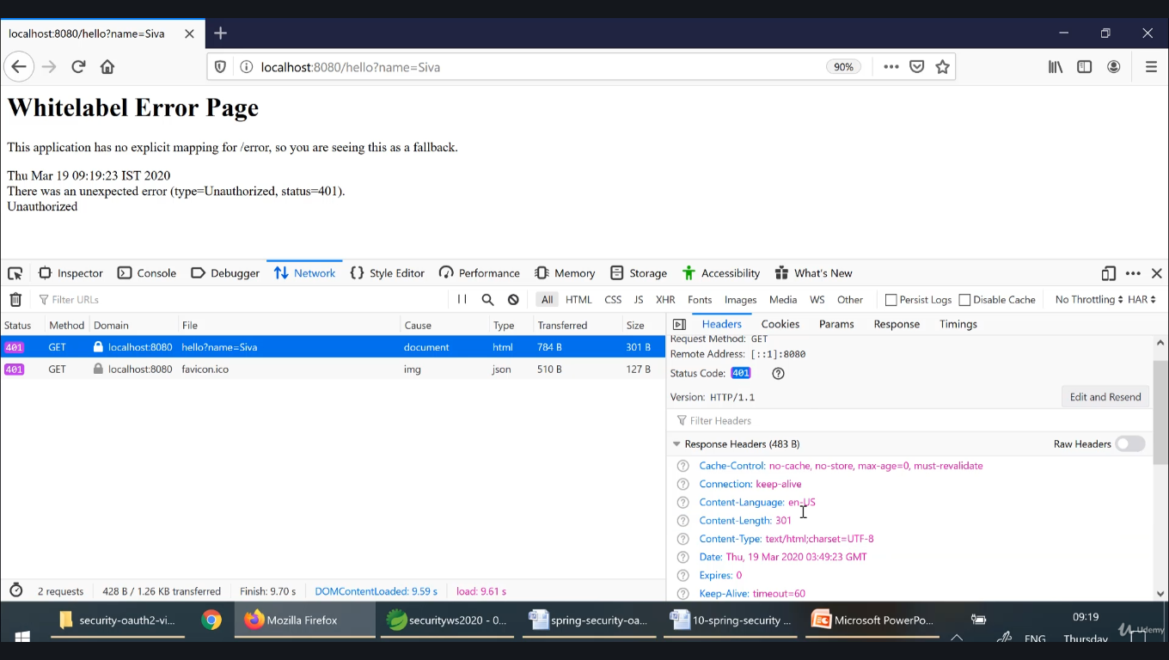

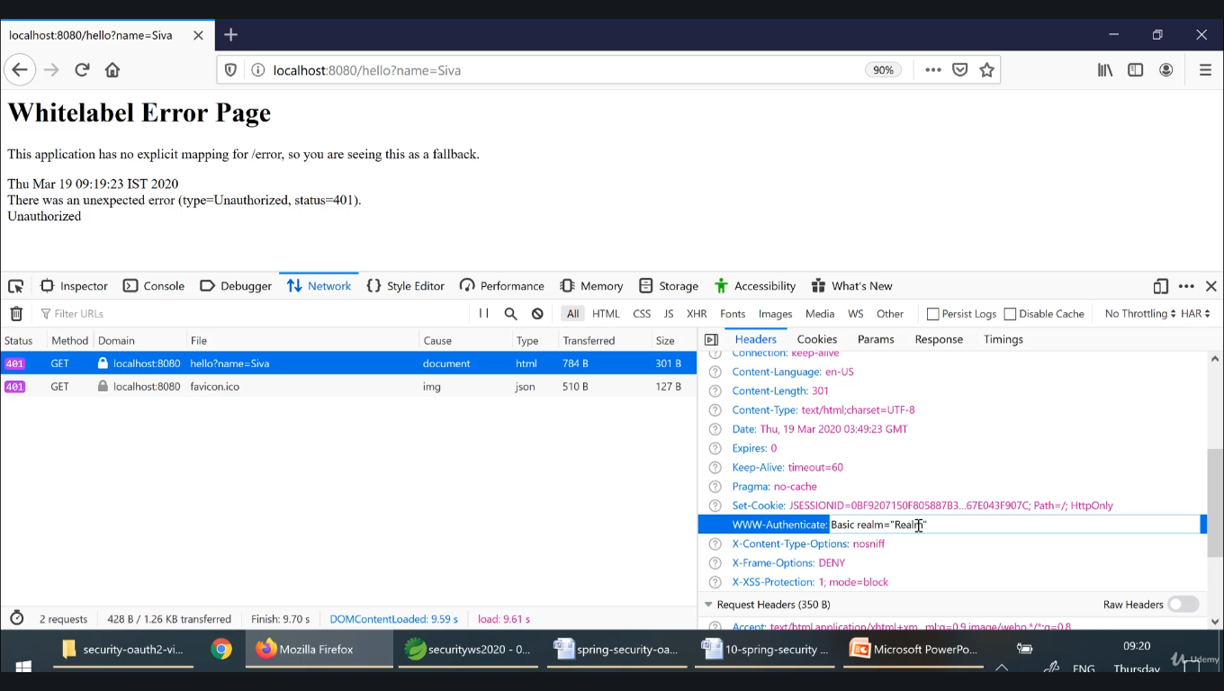

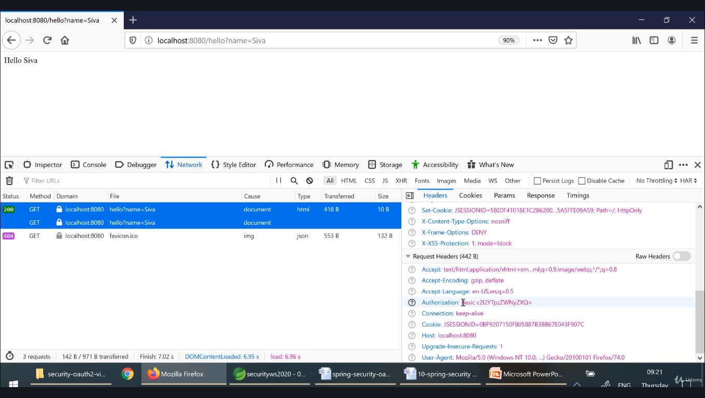

**Browser sends base64 code as**

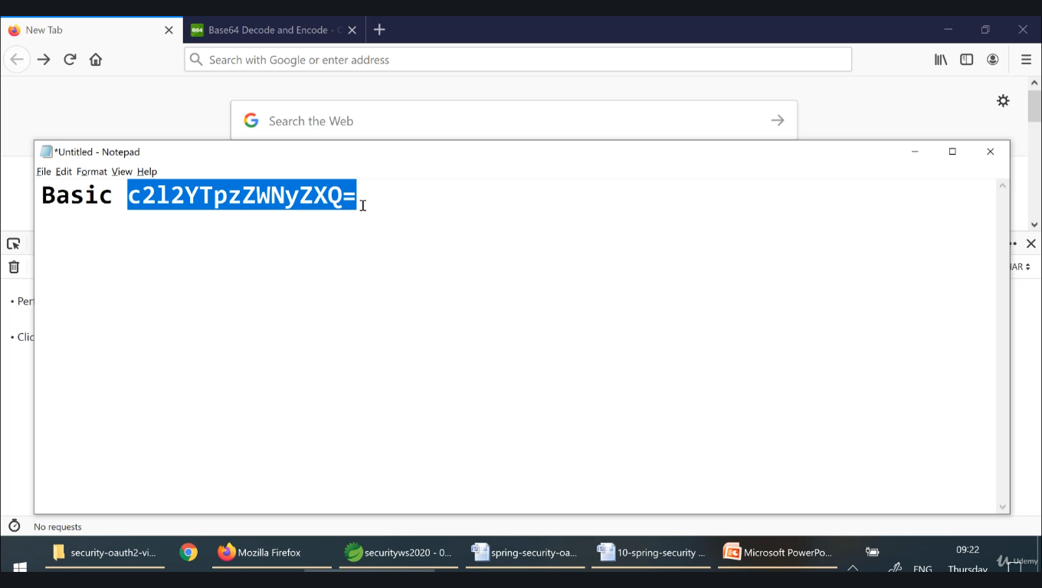

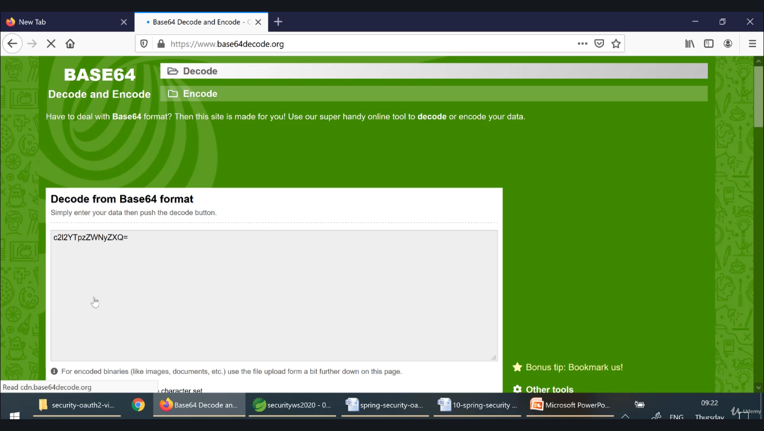

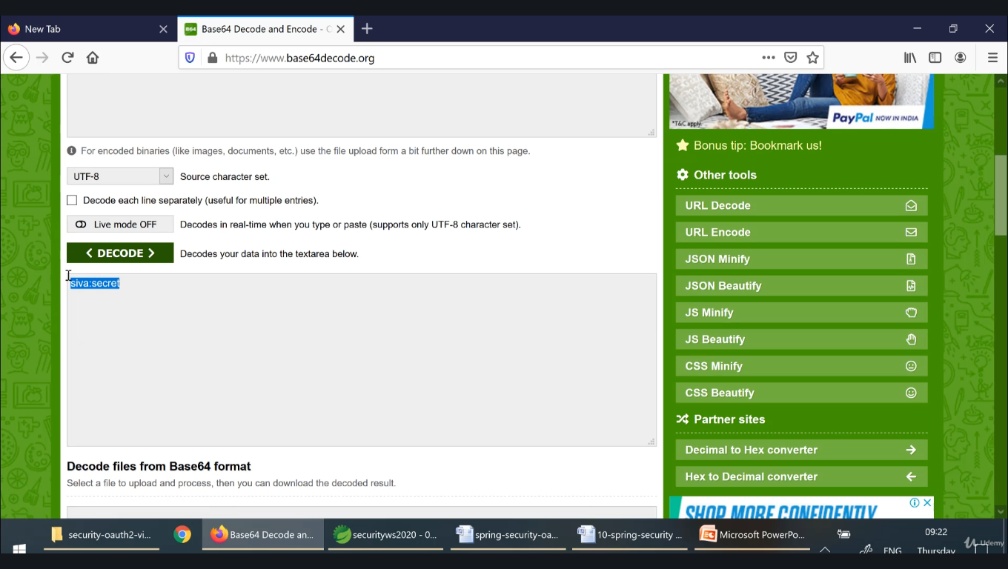

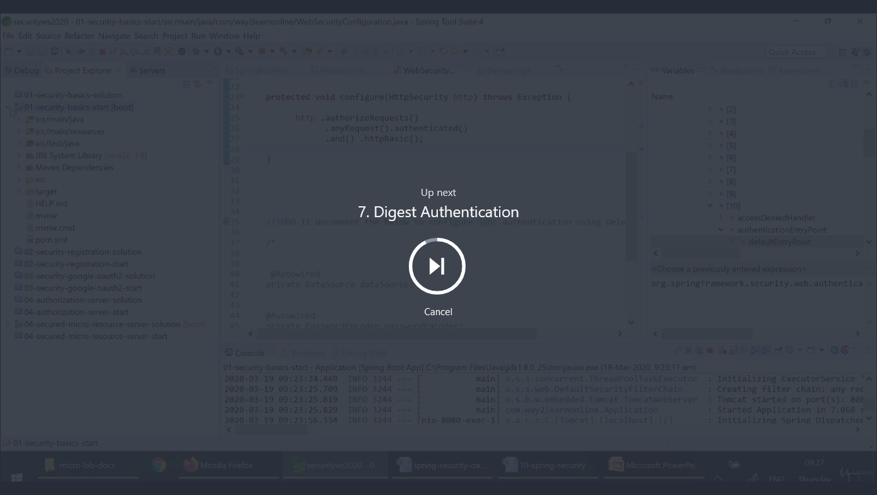

**Problem with basic**

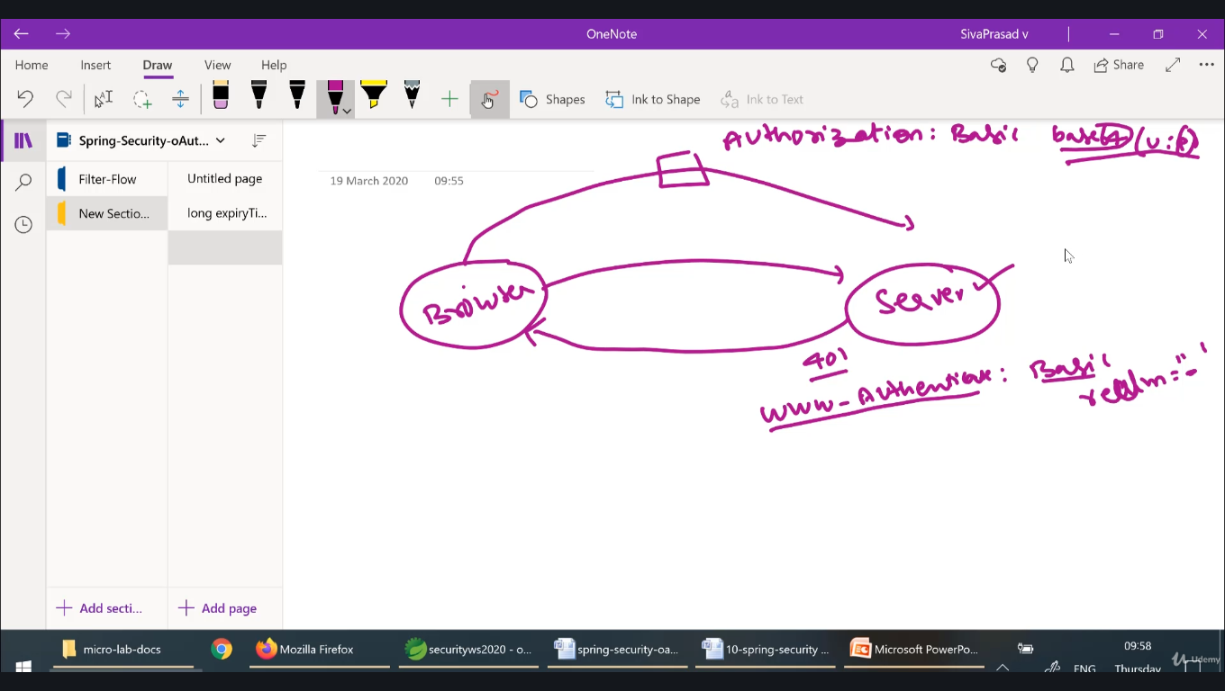

**In basic Authentication any intruder intercept the request (Authorization: Basic base64(u:p)) can alter the details. Hence we will use digest**

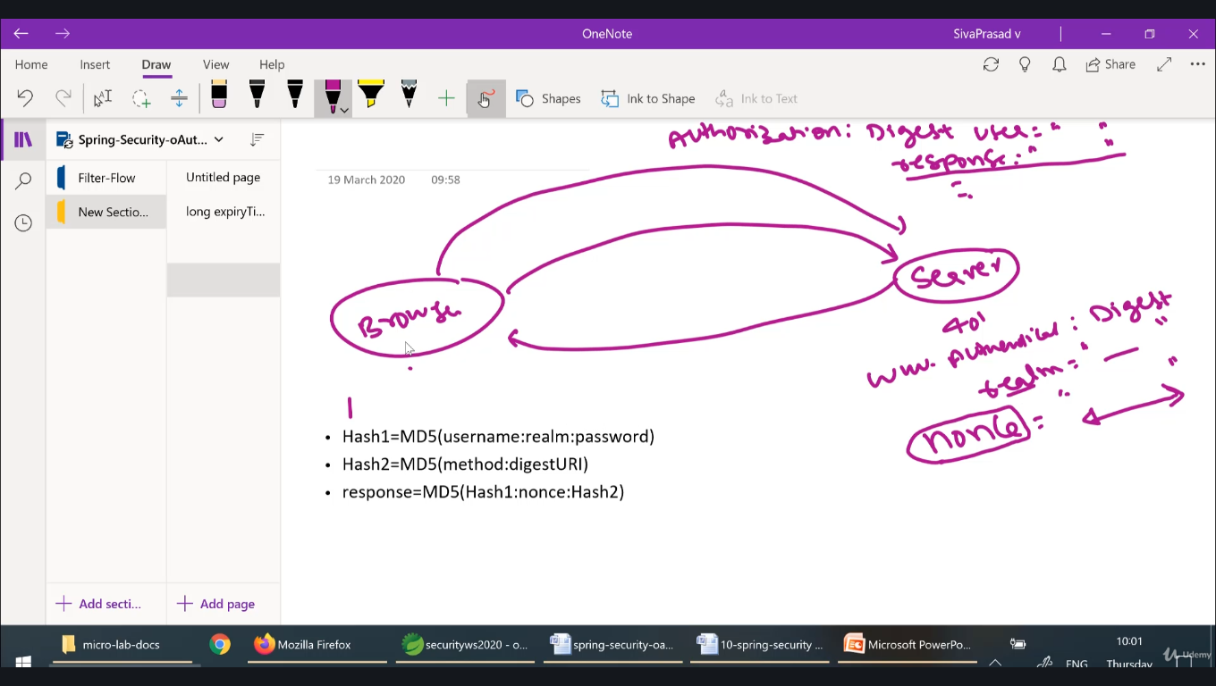

**Server sends nonce to the user, then client calculate response using hash1,hash2 send to the server. Then server check whether same nonce sent by server and also calculates response using same formula then compare response content and server calculated content if they are matching.**

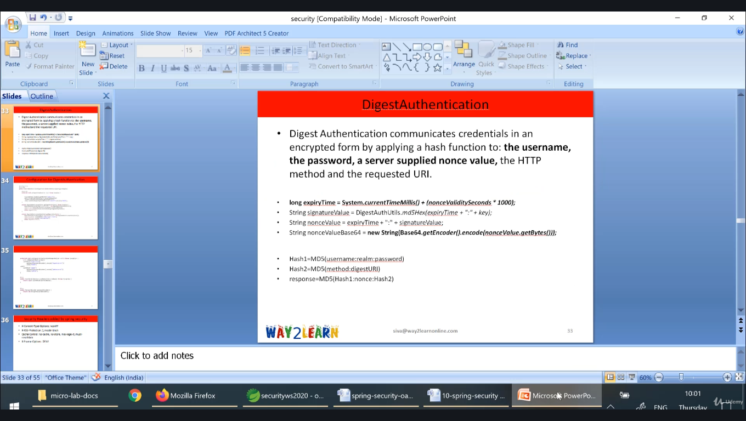

**Filter chain can be any**

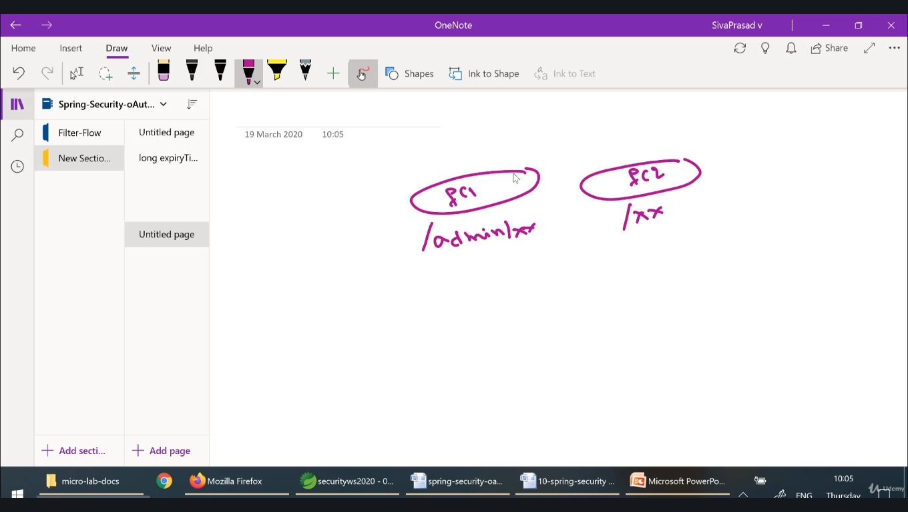

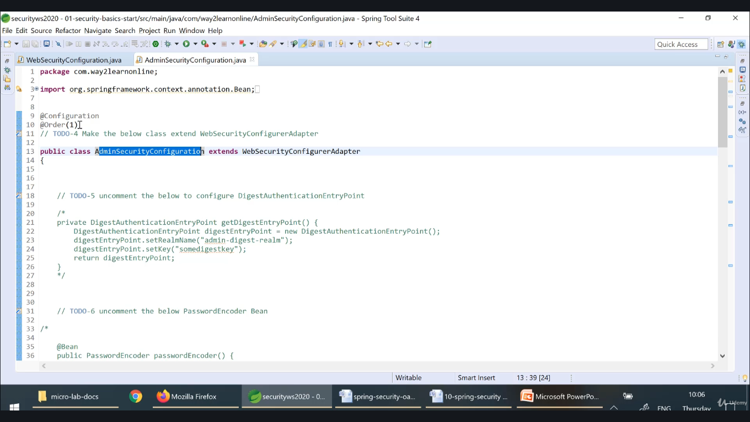

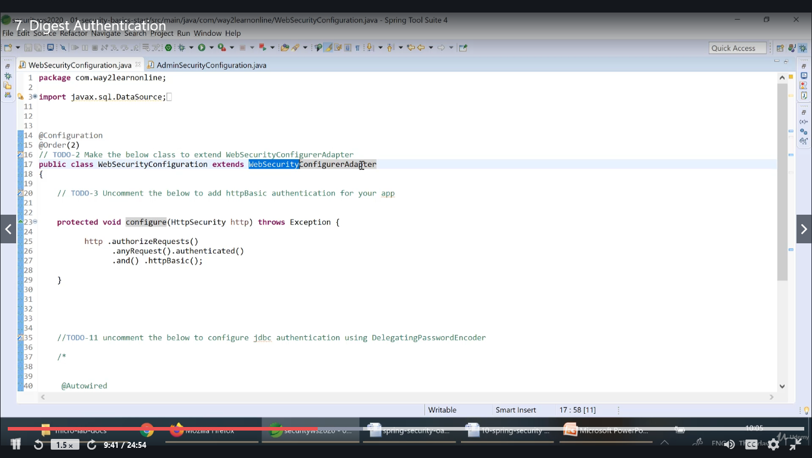

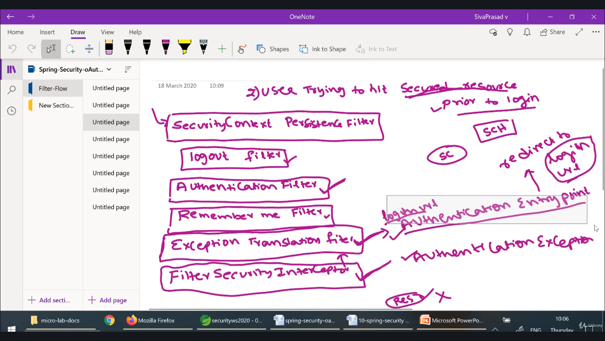

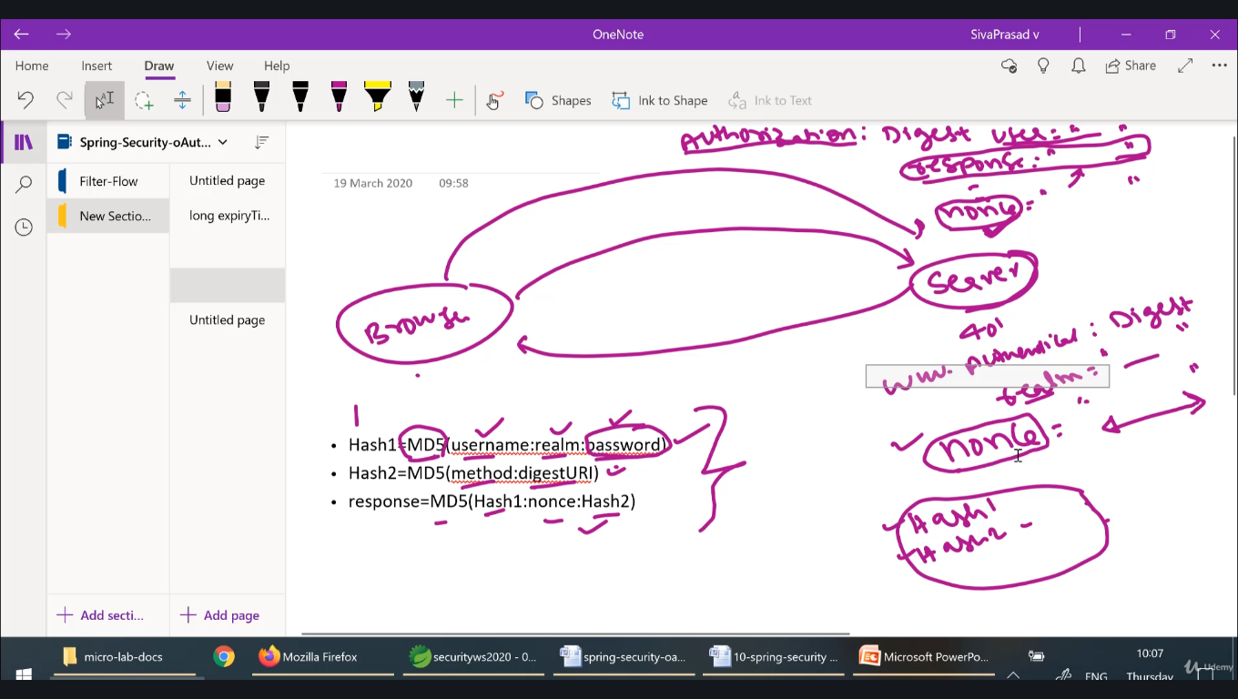

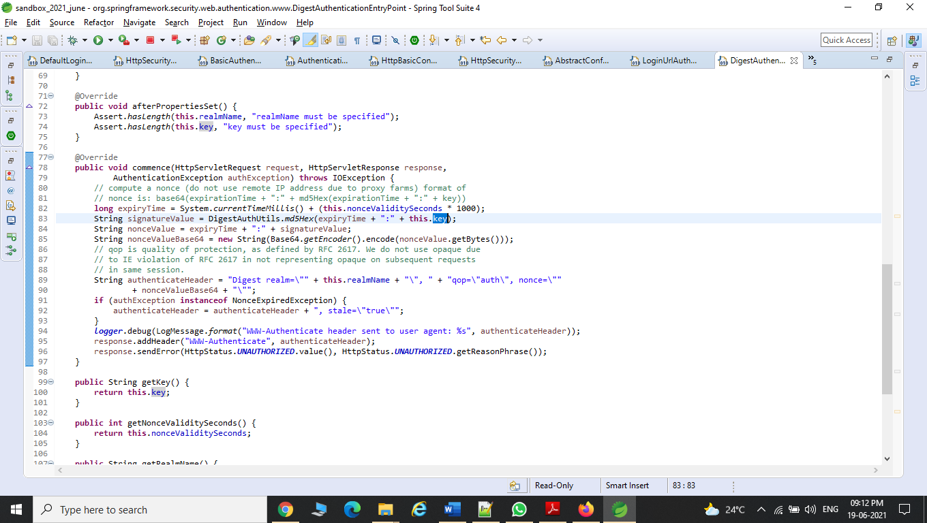

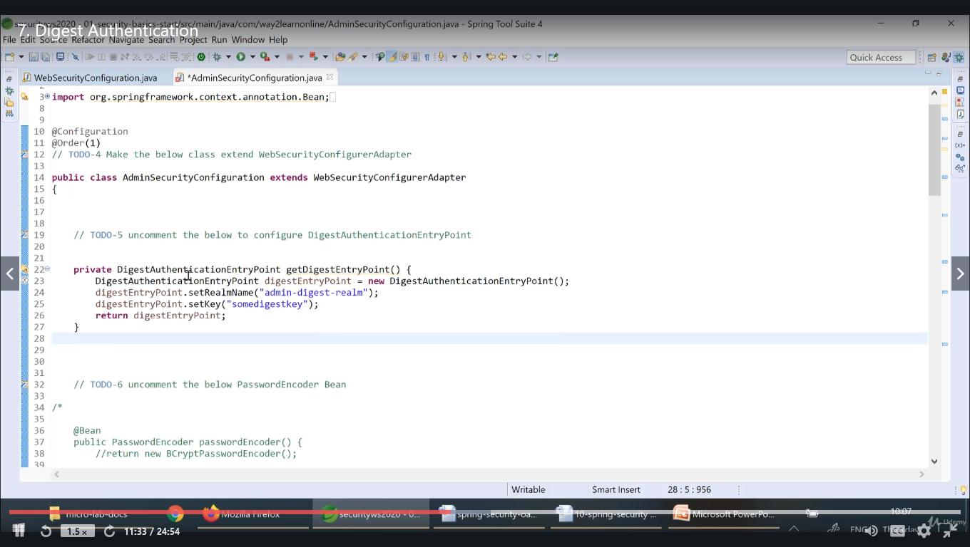

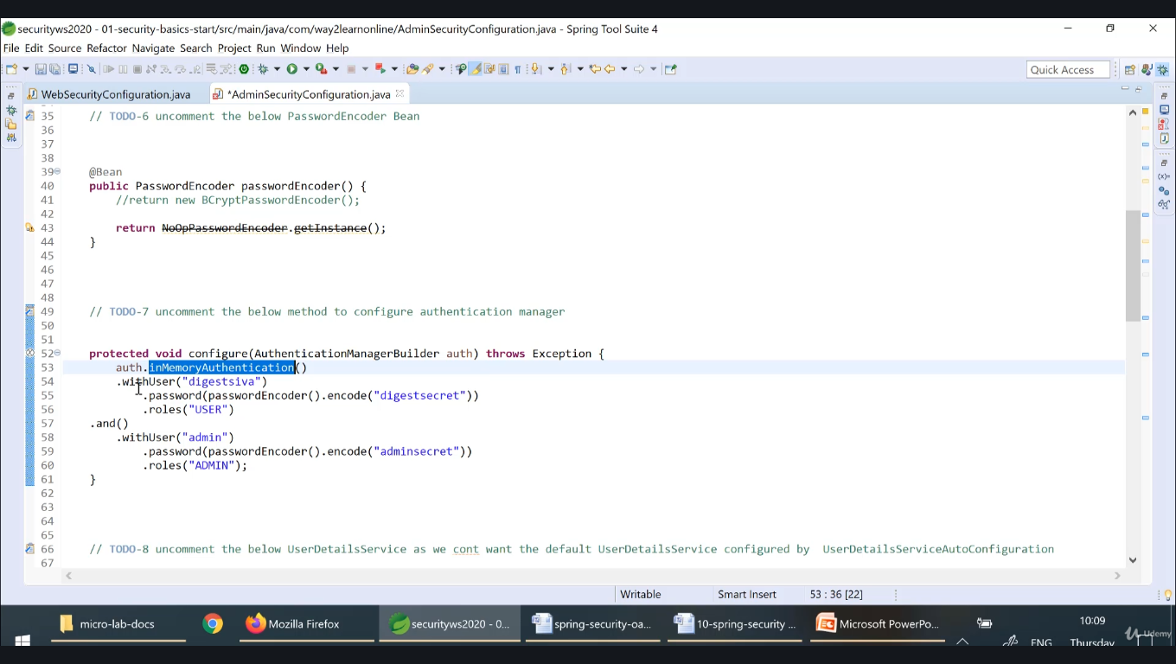

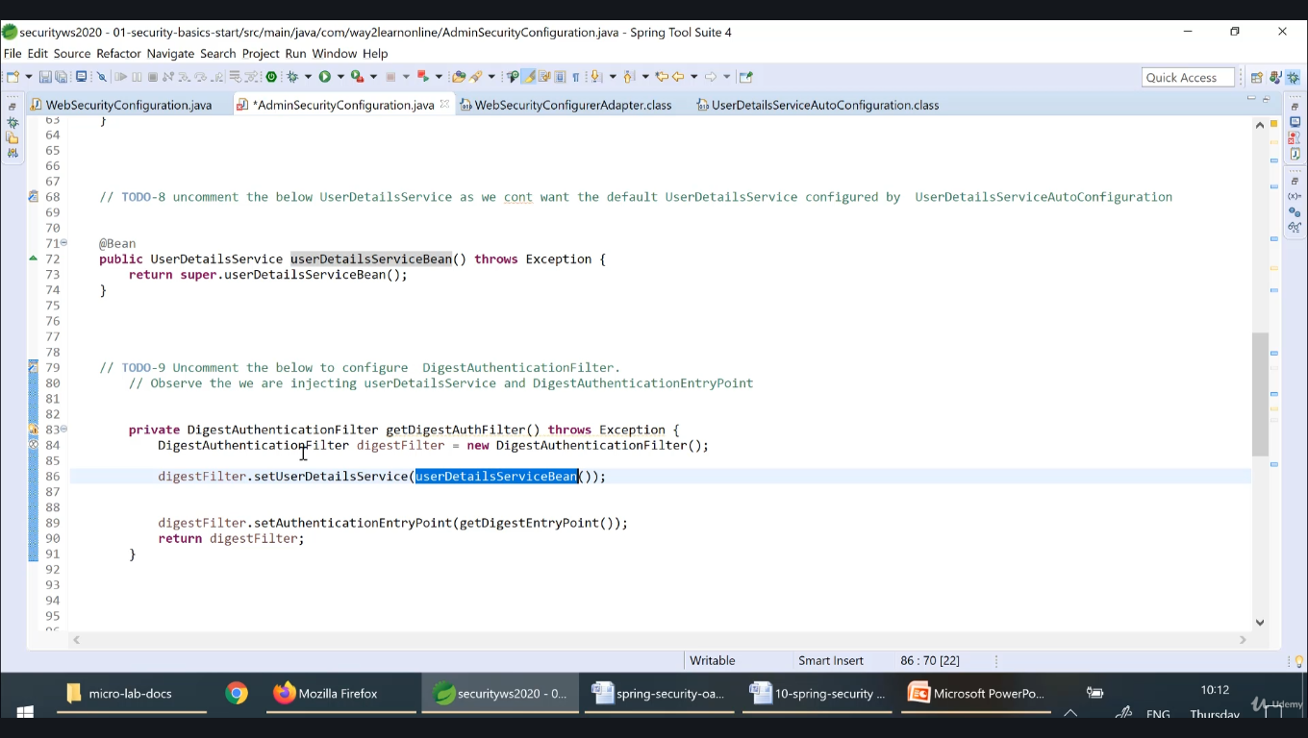

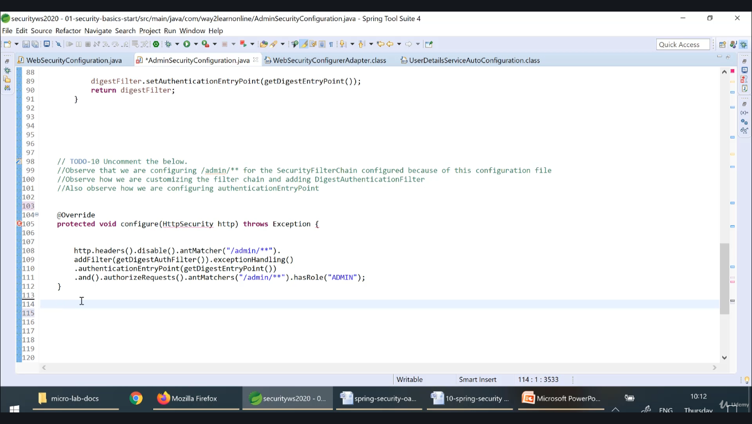

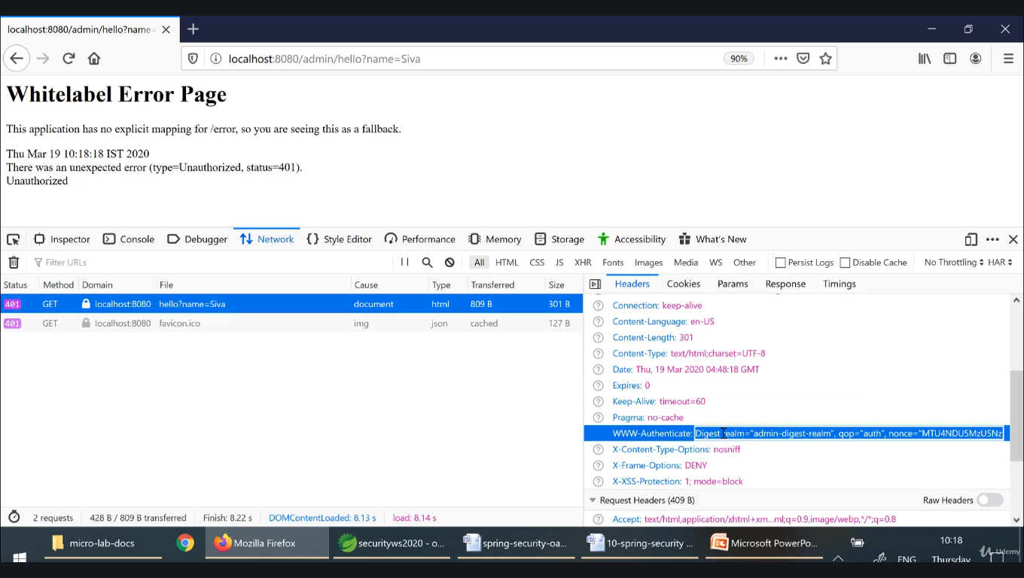

**Credentials in Database:**

**Will use h2 db, hence add this in pom.xml**

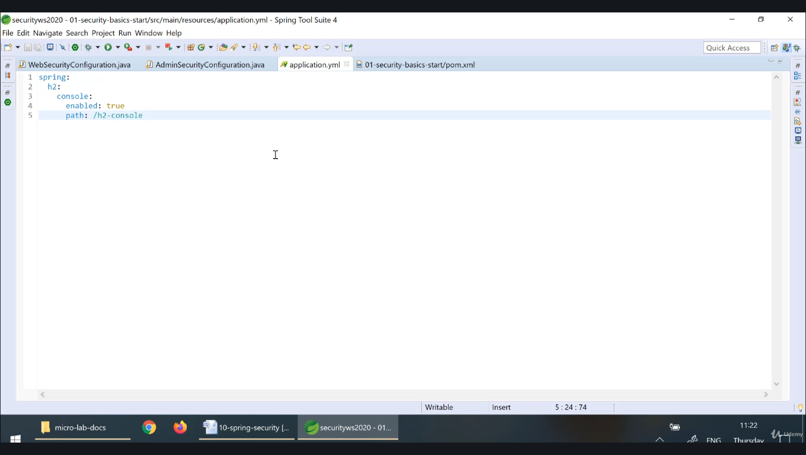

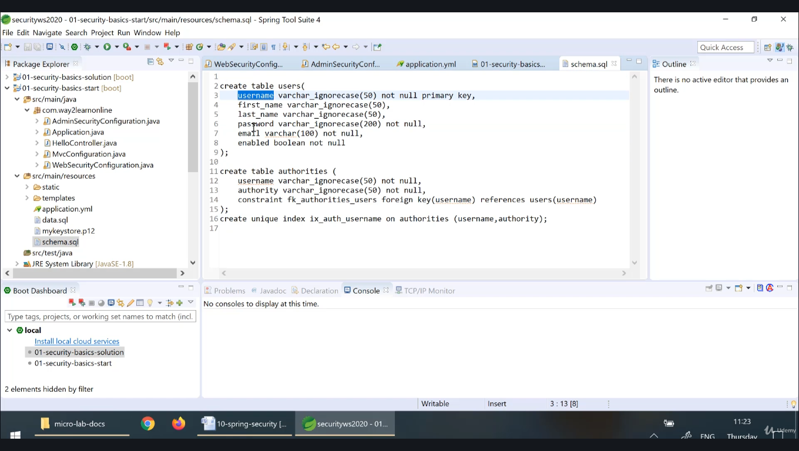

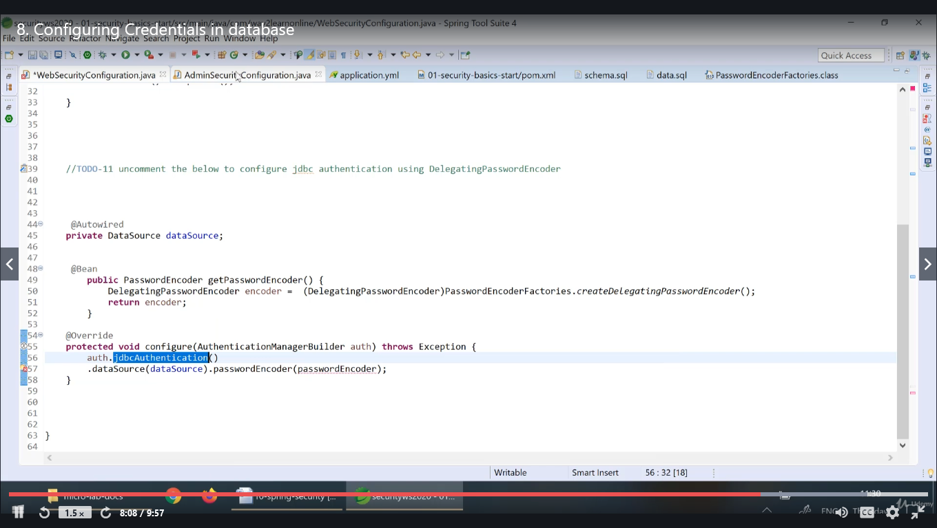

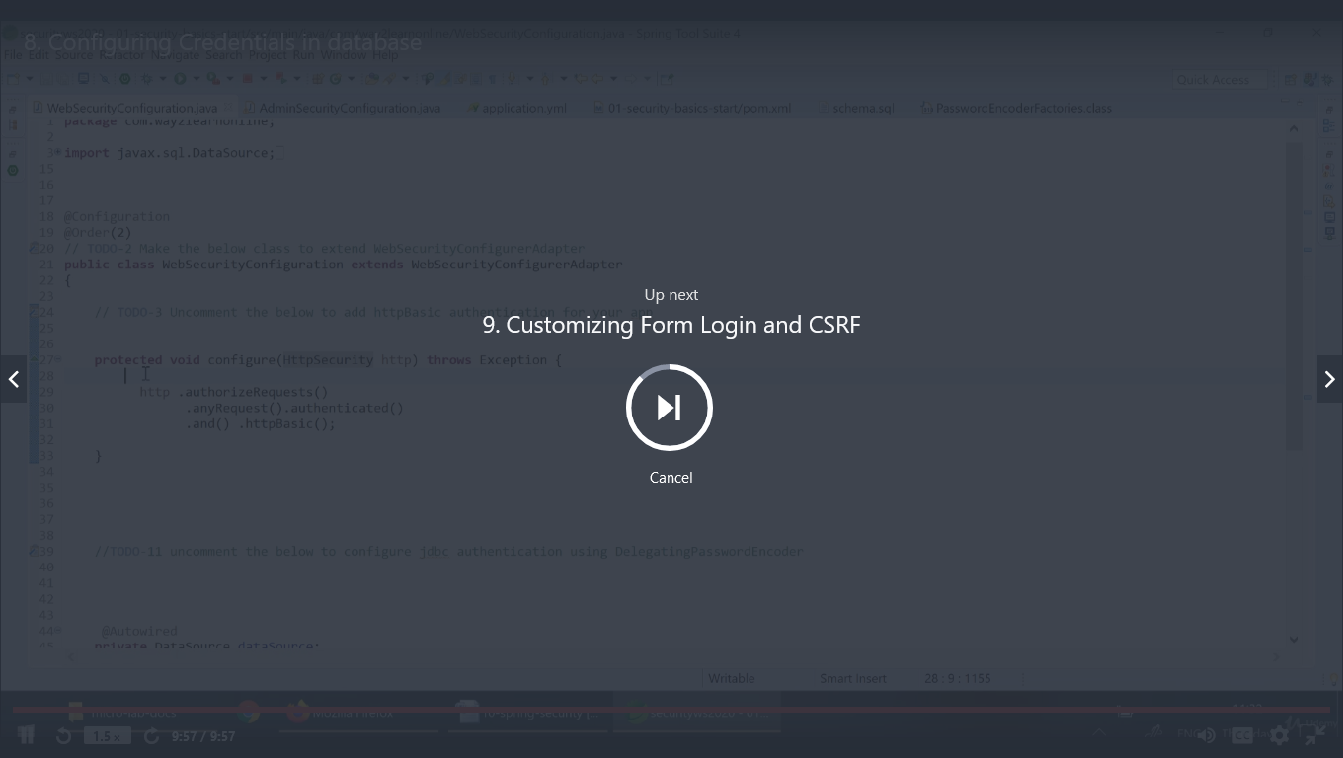

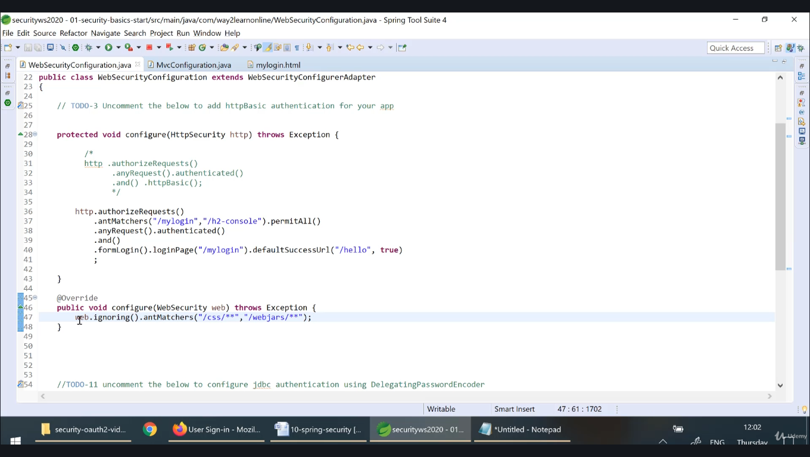

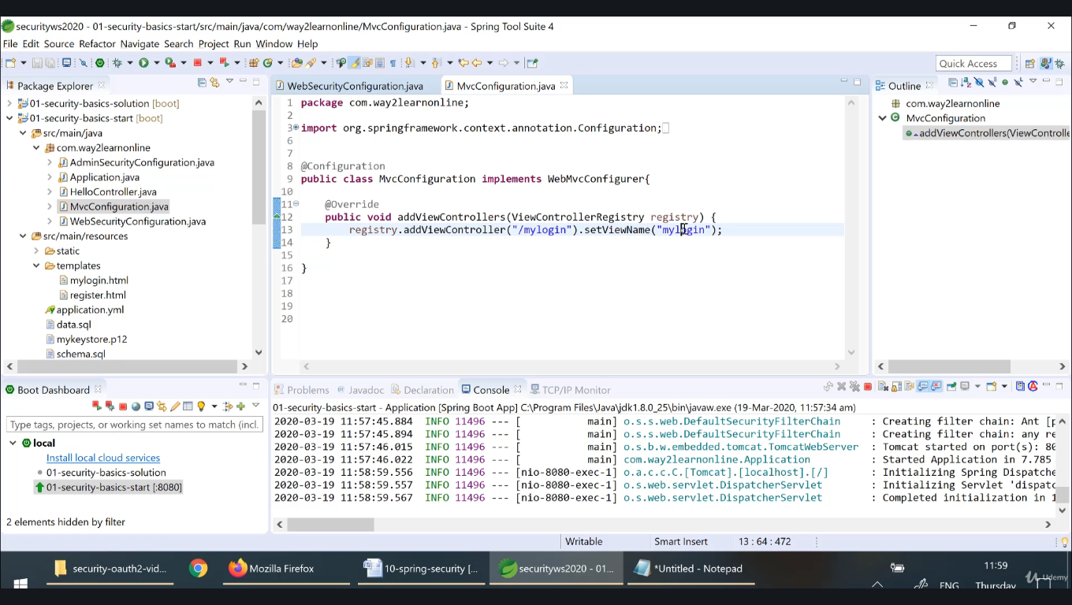

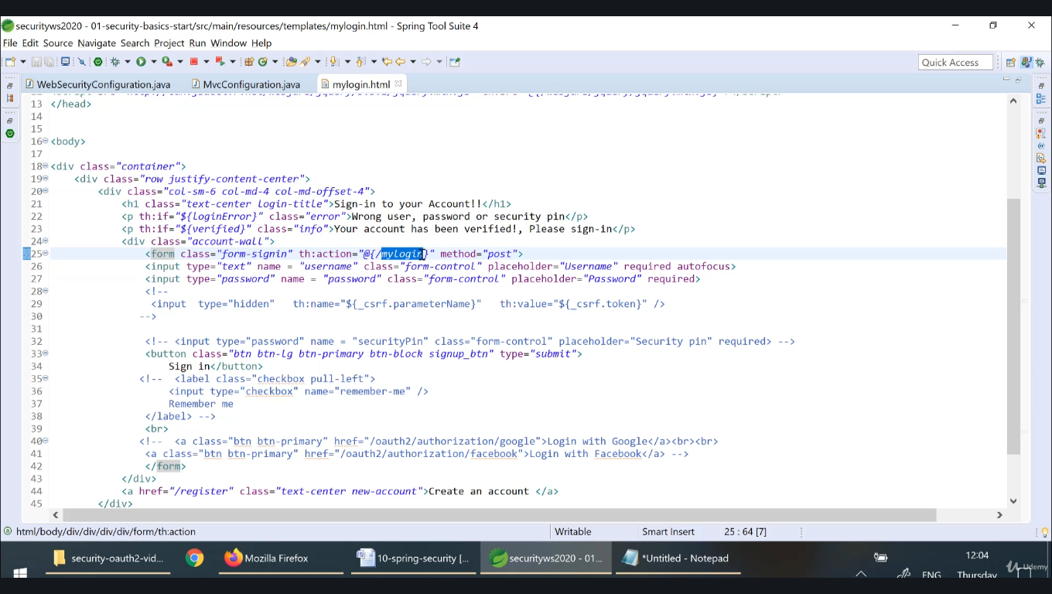

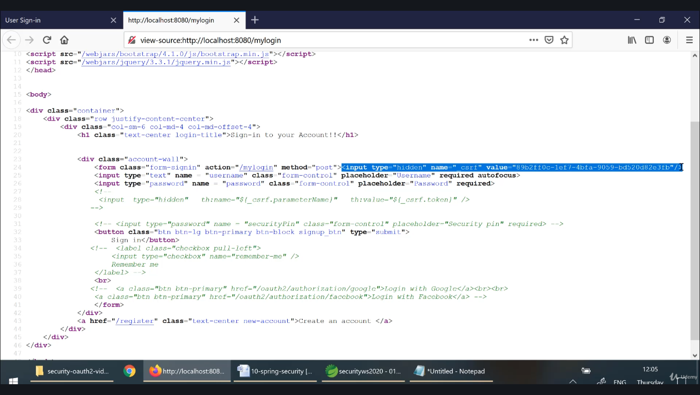

**Because bydefault csrf is enabled**

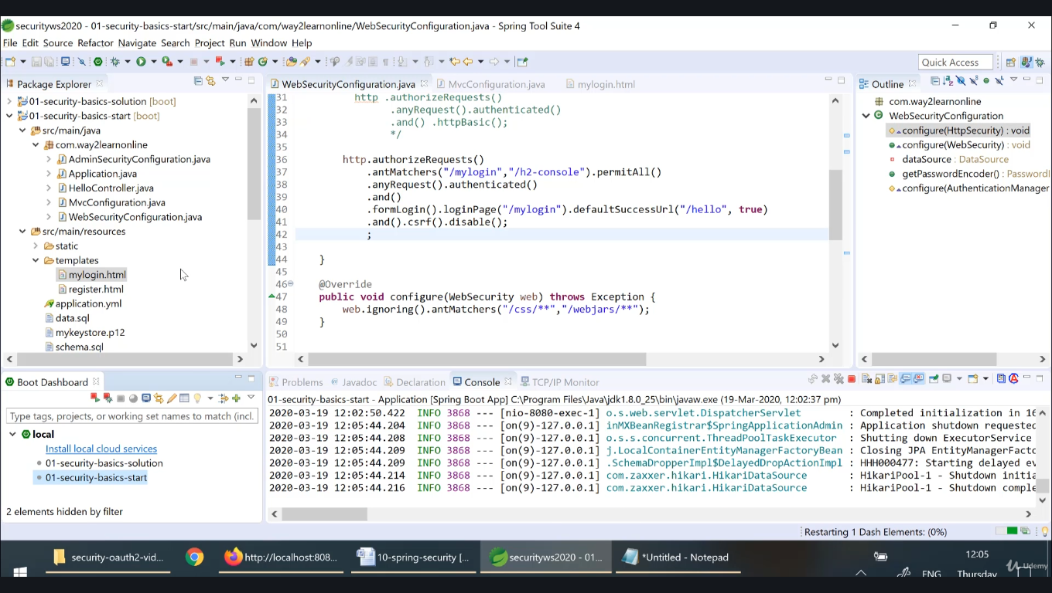

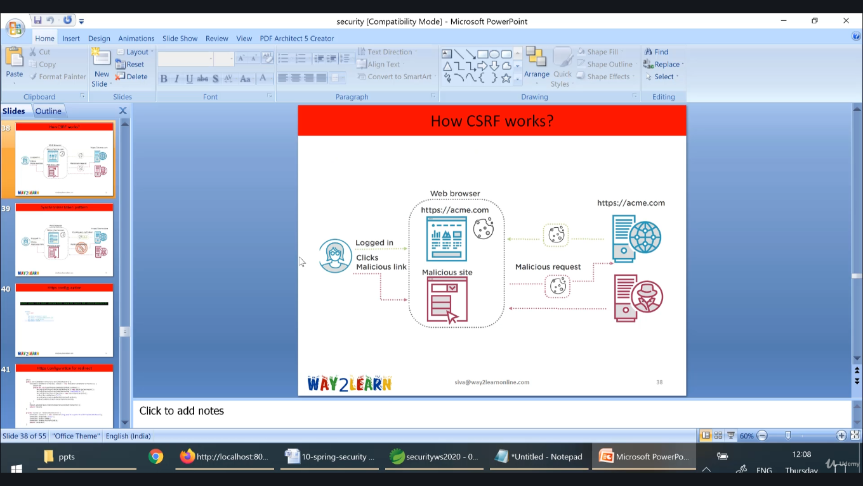

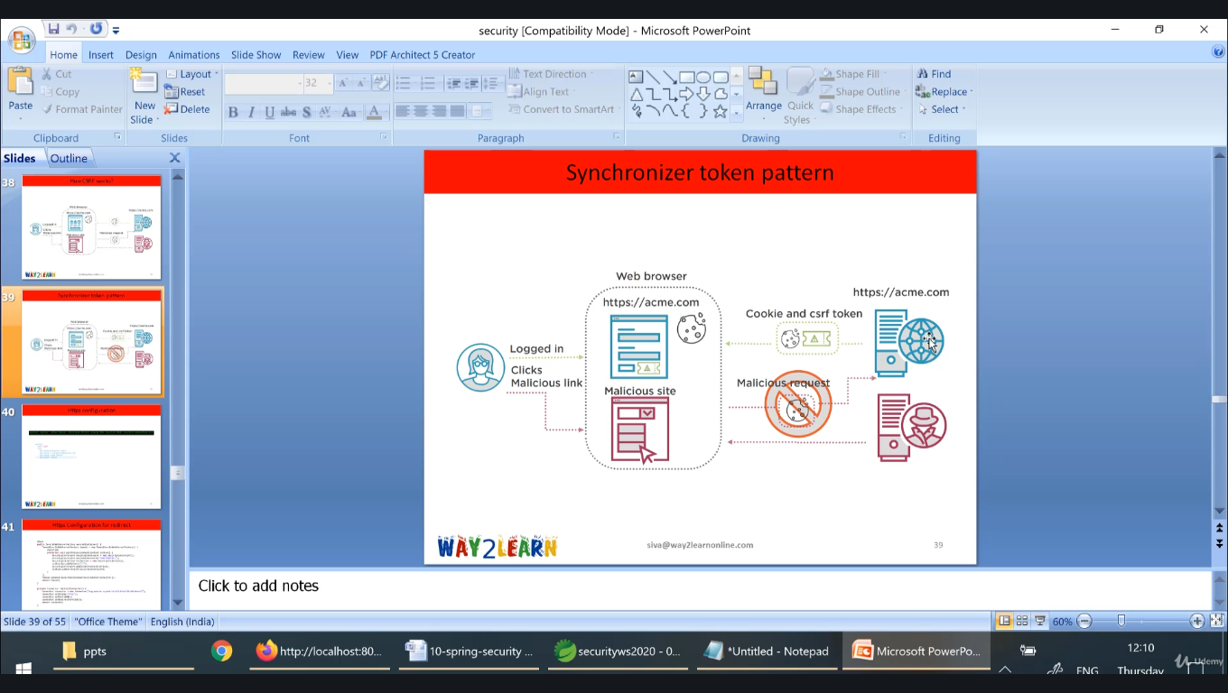

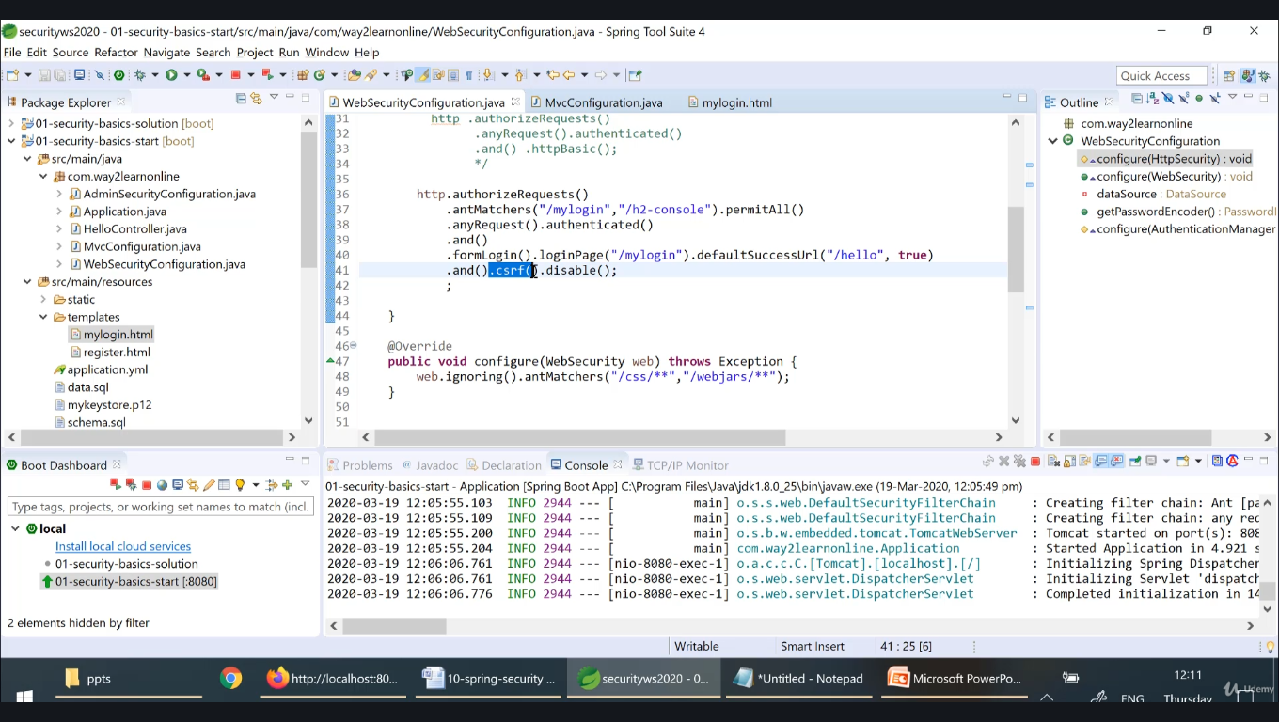

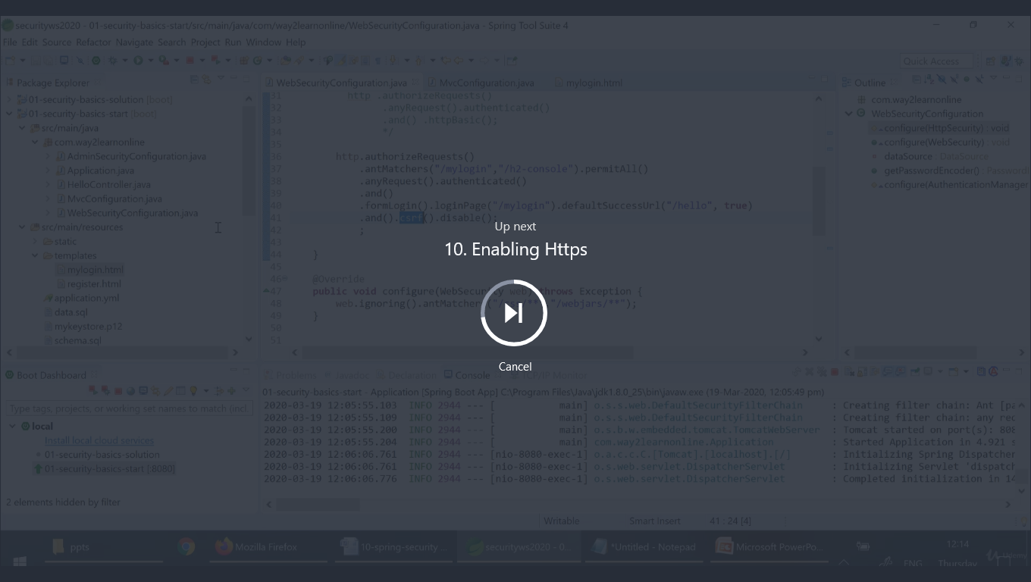

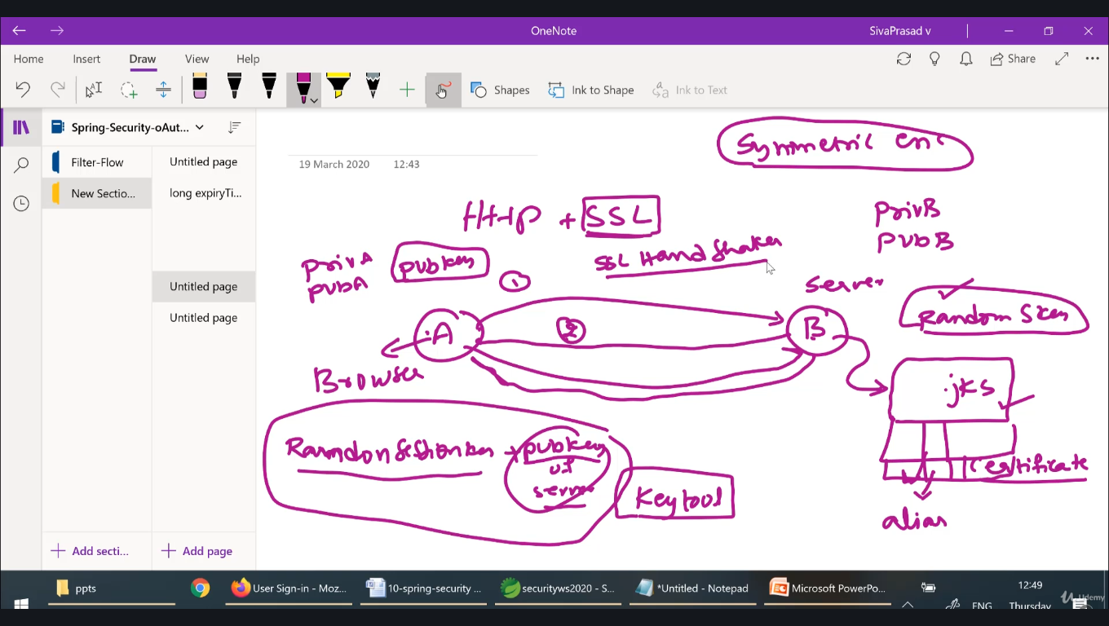

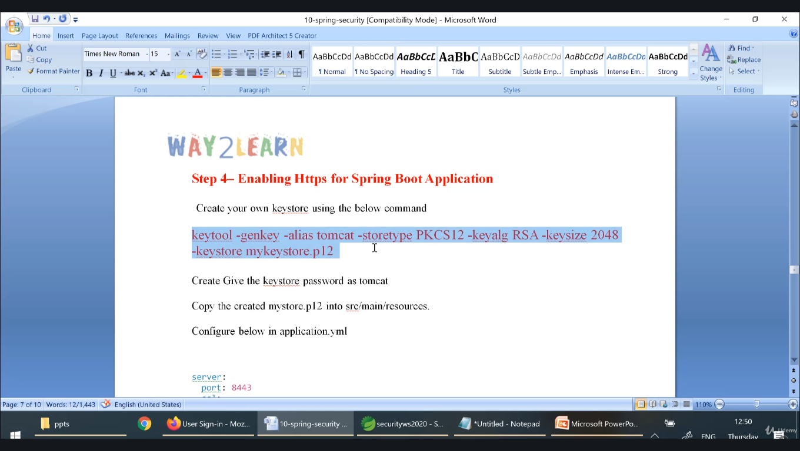

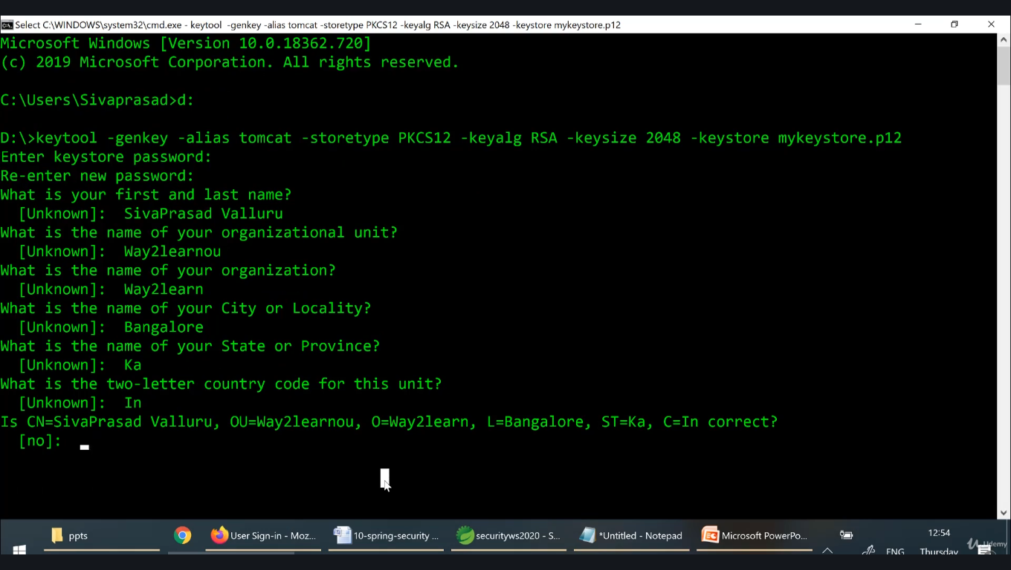

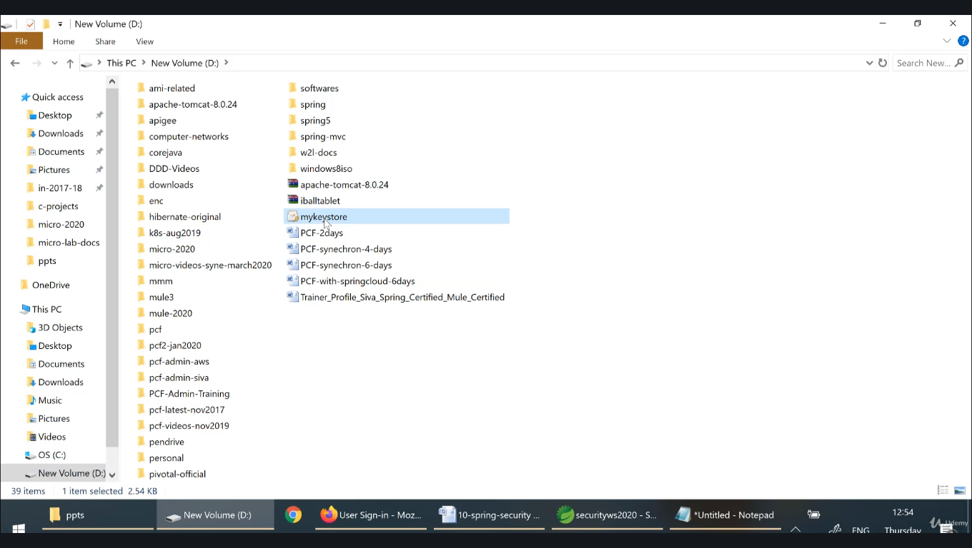

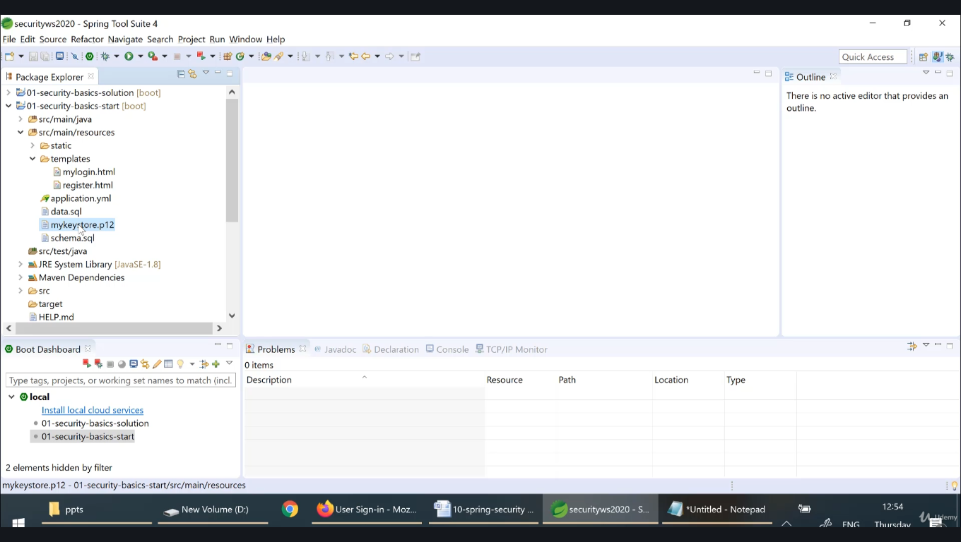

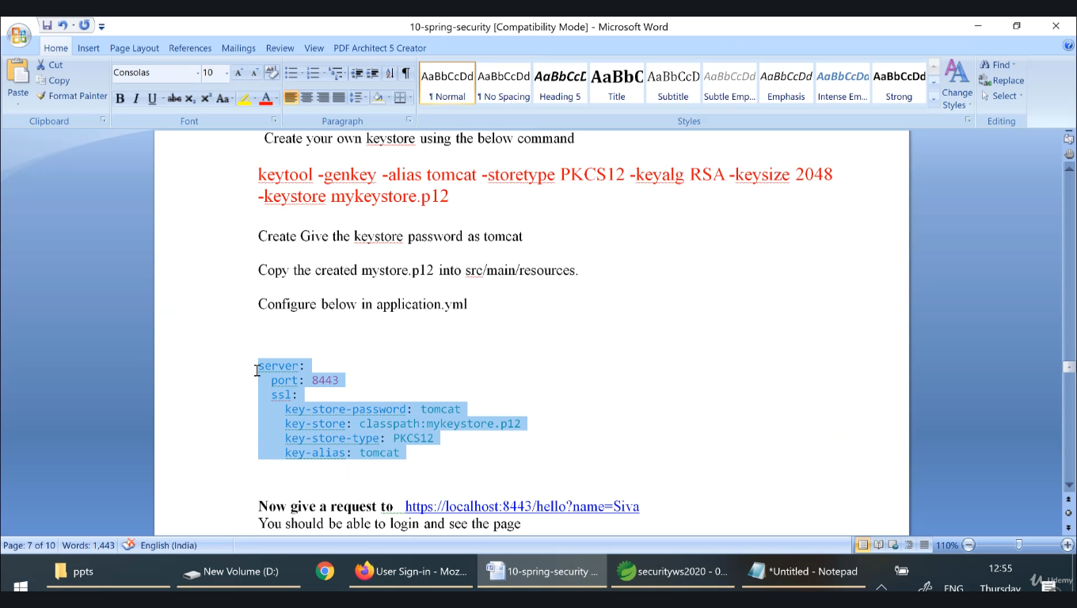

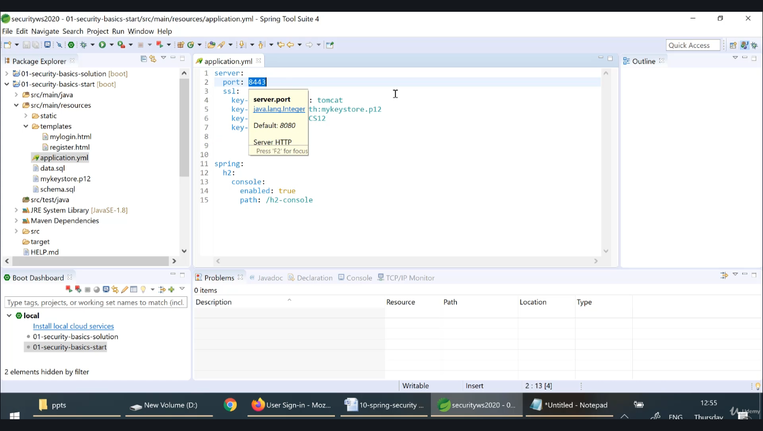

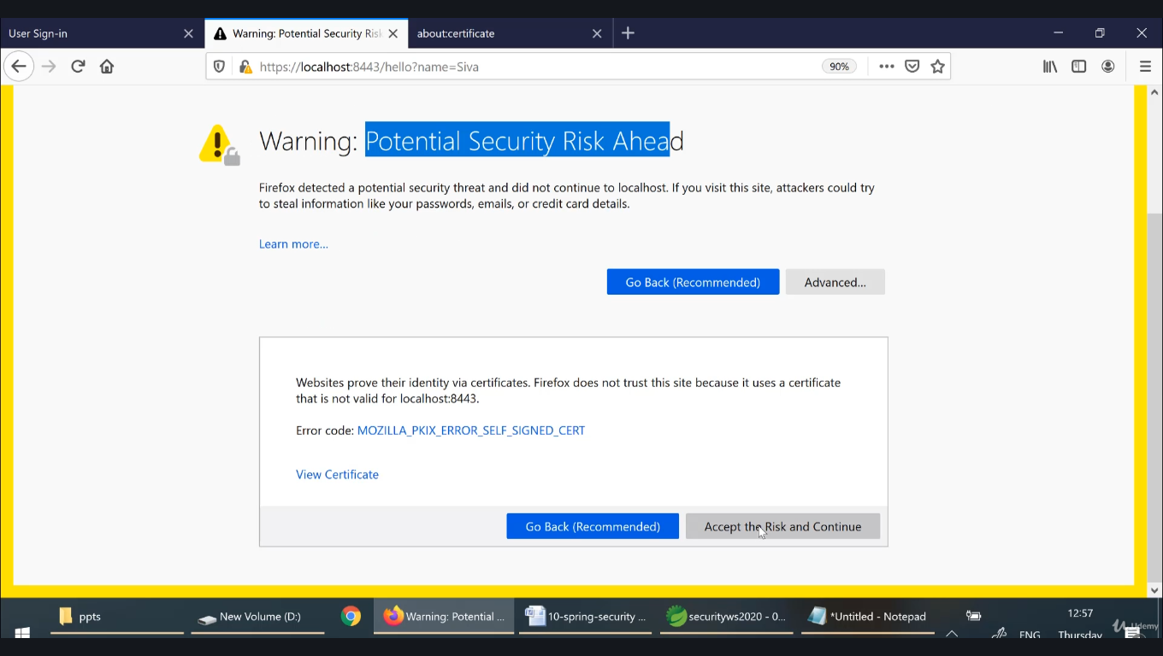

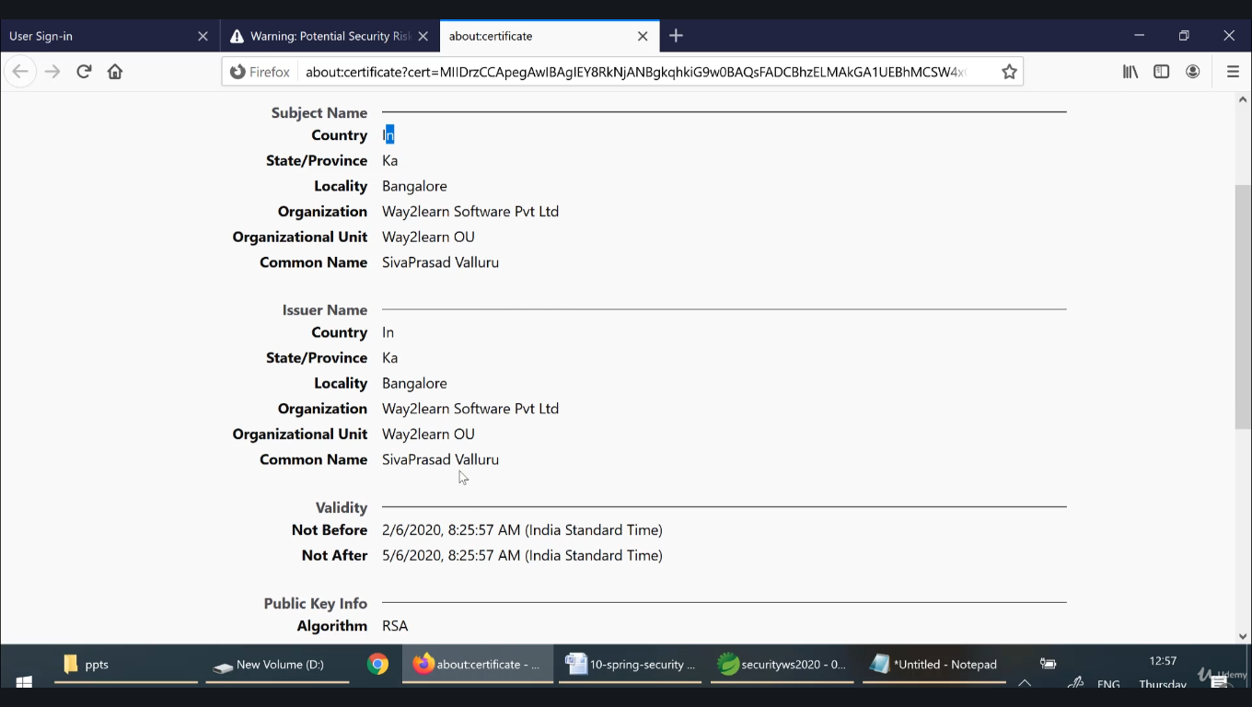

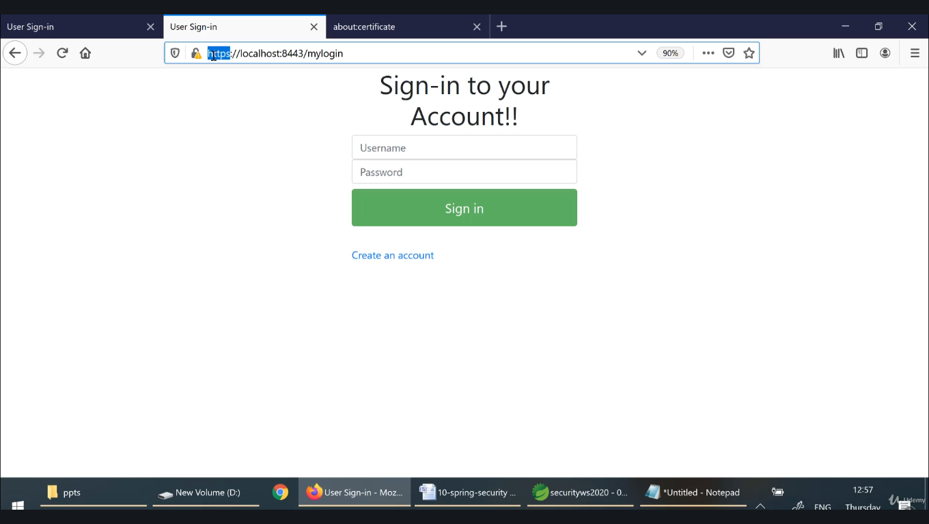

**If any one is accessing the website using http then I want to redirect to https**

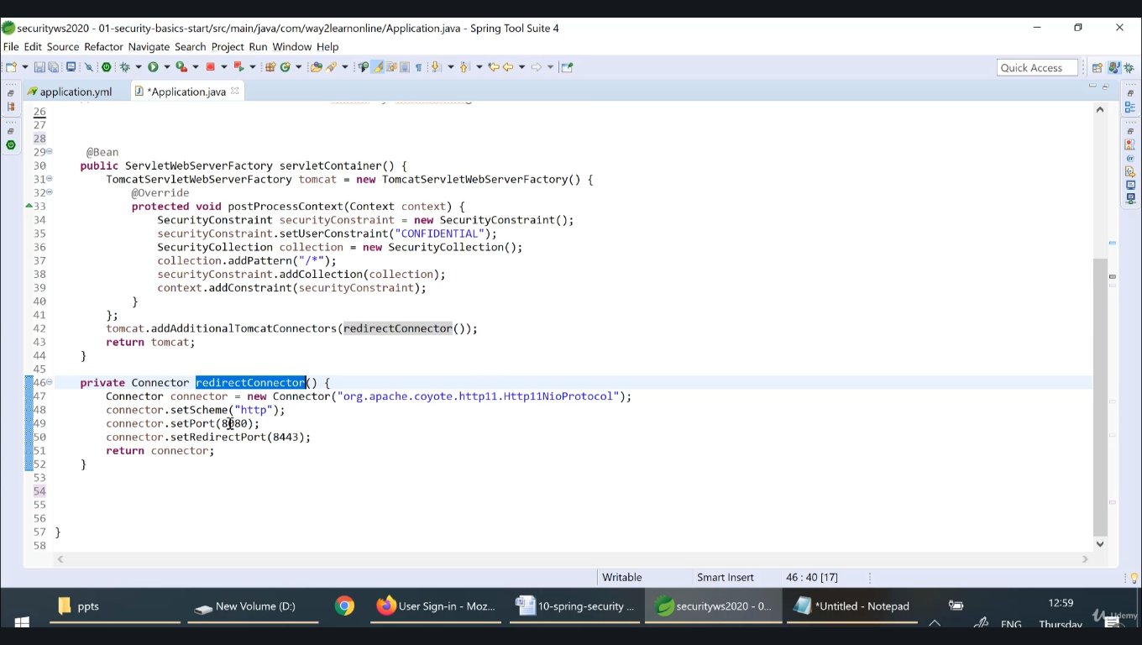

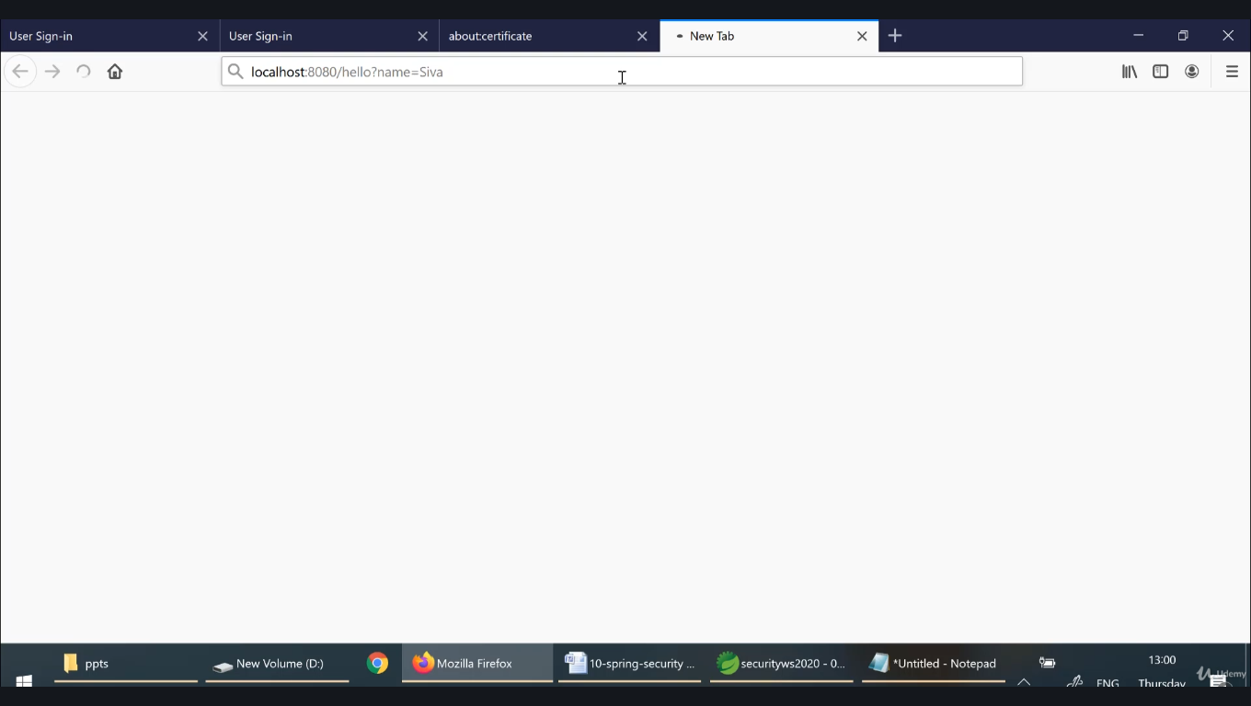

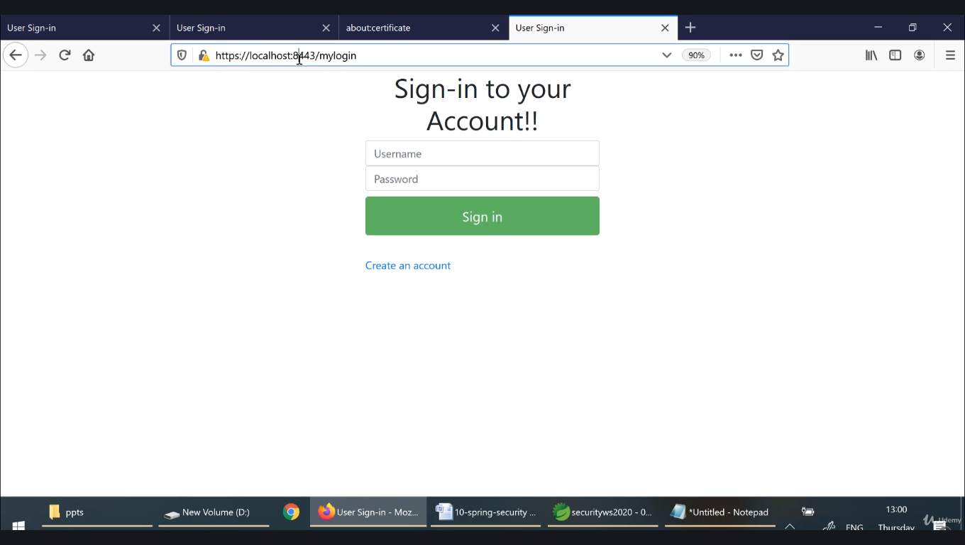

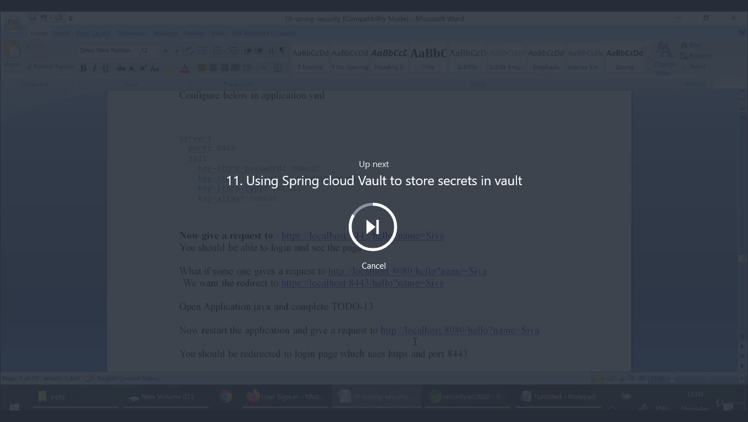

**Problem with the previous solution is password is stored in application.yml which is not the right practice.**